**Unit 4 Commonly Used Software**

**Learning Objectives**

After completing this unit, students will be able to

* Define file folder and a drive
* Create folder and file
* Copy/move a file/folder to another folder/location
* Cut a file/folder and paste it to another folder/location
* Delete a file/folder
* Get familiar with menu bar, tool box and color box
* Draw freehand shapes with the pencil
* Use pen, shapes, spray, brush and other various tools to draw and color different shapes
* Copy/paste an image into Paint and modify it
* Save a file
* Recognize Word 2016
* Create new document using Office button menu
* Edit text and explain uses of ribbon, tabs and groups
* Type text into document
* Copy, cut, paste and delete text
* Know font styles and size
* Change alignment and case of text
* Check spellings and grammar
* Save and Print a document
* Compare different viewing modes
* Apply various formatting commands to document
* Explain functions undo, redo, find and replace
* Make tables
* Use bullets and numbers

## Managing Files and Folders

### Definitions

* **File**

A **file** is a collection of data stored in one unit, identified by a [filename](https://pc.net/glossary/definition/filename). It can be a document, picture, audio or video stream, data library, [application](https://pc.net/glossary/definition/application), or other collection of data.

Files can be opened, saved, deleted, and moved to different [folders](https://pc.net/glossary/definition/folder). They can also be transferred across network connections or [downloaded](https://pc.net/glossary/definition/download) from the Internet. A file's type can be determined by viewing the file's [icon](https://pc.net/glossary/definition/icon) or by reading the [file extension](https://pc.net/glossary/definition/fileextension). If the file type is associated with a specific application, double-clicking the file will typically open the file within the program.

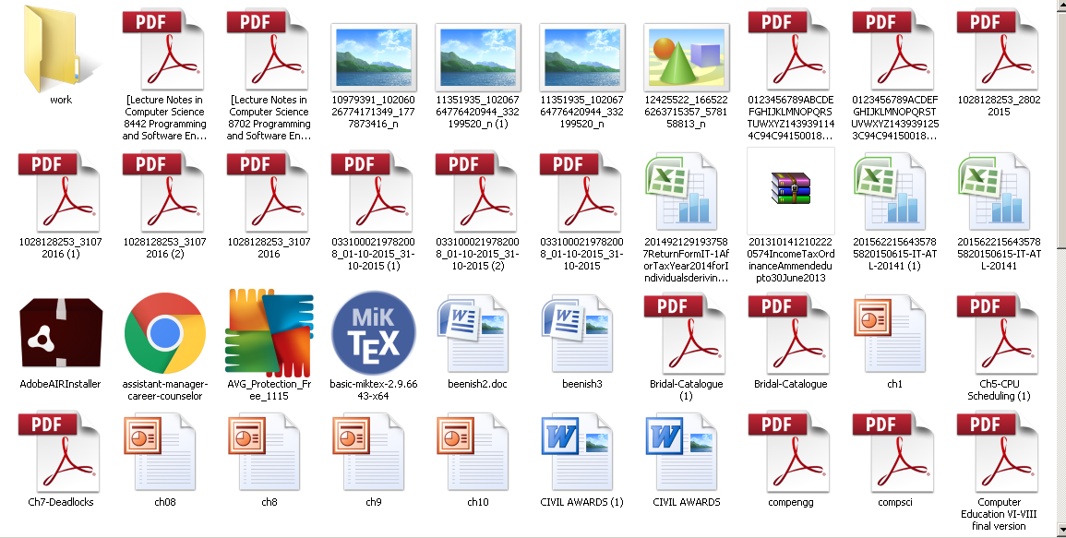

Figure 4.1 (a) Files

* **Folder**

Just like real world folders, **folders** on your hard drive store files. Folders allow people to organize their files in a way that makes sense to them. For example, you can store all your photos in a folder named "Pictures," all your assignments in a folder named "School Work," and all your drawings in a folder named "Paint". All these folders might reside within a folder called "My Documents."

While folders can store several gigabytes of data, folders themselves hardly take up any space on the hard drive. This is because the folders are really just pointers to files and other folders, telling the computer where they are located.

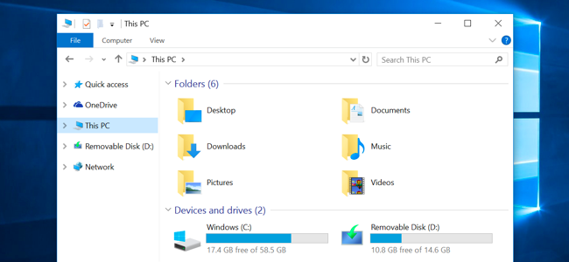

Figure 4.1 (b) Folders

* **Drive**

A **logical drive** or **drive** is a drive space that is logically created on top of a physical hard disk drive. It is primarily used to organize the storage capacity of a physical disk drive into smaller and logical drive units. A physical disk drive can have one or more drives (for example C, D, E drives) depending on the capacity of the base physical hard disk drive and the operating system support. The data stored in a logical drive is directly stored on the physical drive but is logically separated from other logical drives.

The **C drive** (C:) is the main hard disk partition which contains the operating system and the related system files. In Windows operating systems, the C drive is represented as “C:\”.

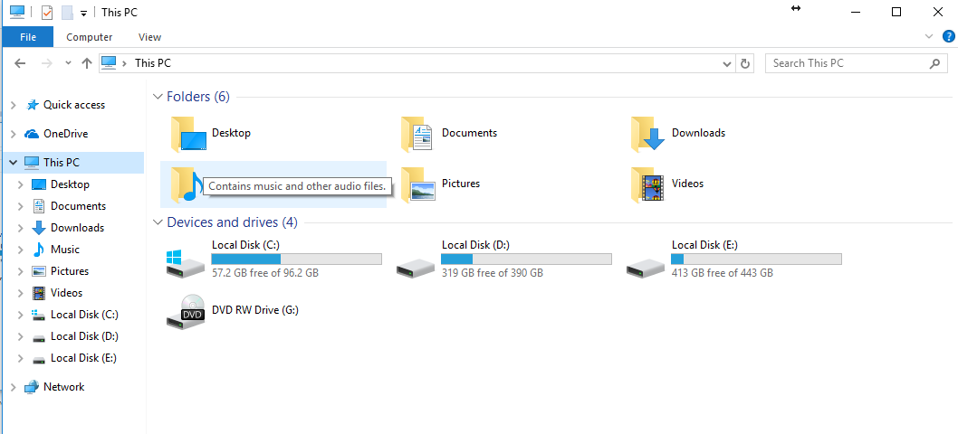

Figure 4.1 (c) Drives

### How to Create a Folder and File

**Folder**

Creating a new folder is really easy and straight forward in Windows 10

* Just navigate to the drive you want to create the folder in.
* Click "New folder" in the Home tab

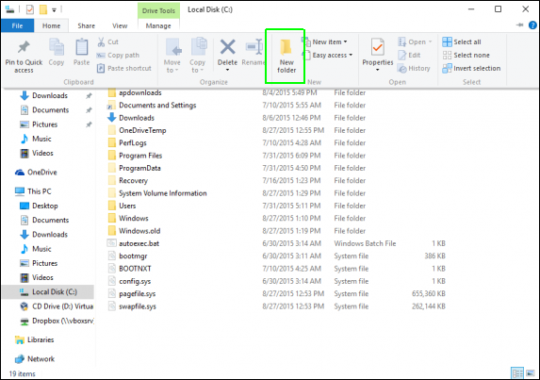

Figure 4.1 (d) New Folder

* **Enter your desired folder name** to replace "New folder" and hit Enter.

Activity 1

In drive D: of your computer create a folder named as

*Activity 1*.



**File**

* Navigate to the folder or desktop, you would like to create your file. For example, My Documents.

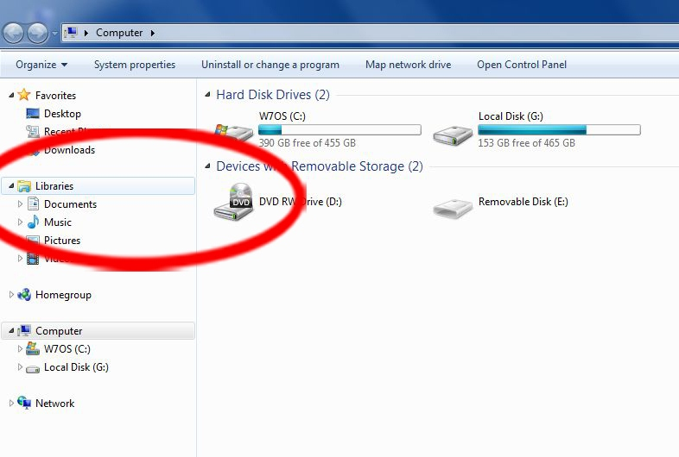

Figure 4.1 (e) Navigate to a folder

* Right click anywhere in the empty section of the folder window or desktop.

### Select "New" from the context menu.

* Select the type of file you'd like to create.

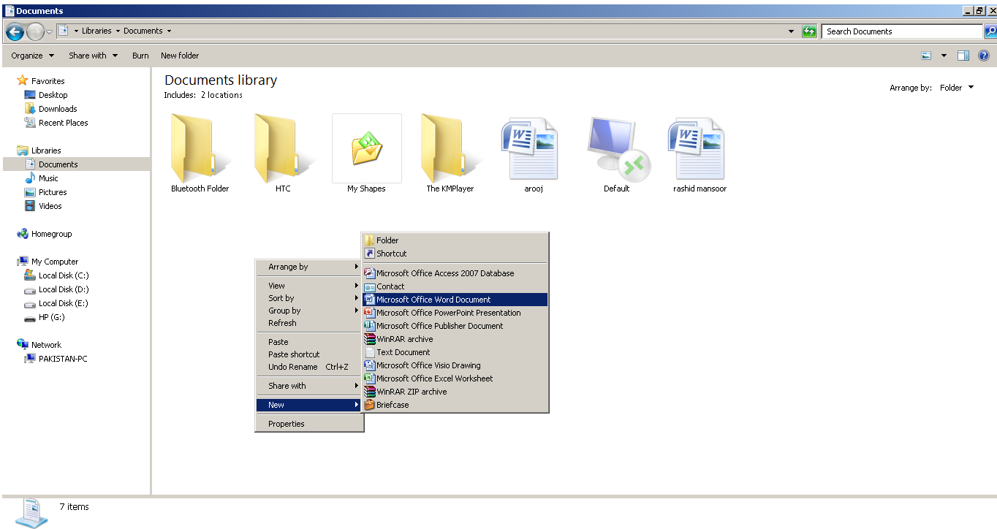

Figure 4.1 (f) Type of file

* Enter a name for the newly created file.

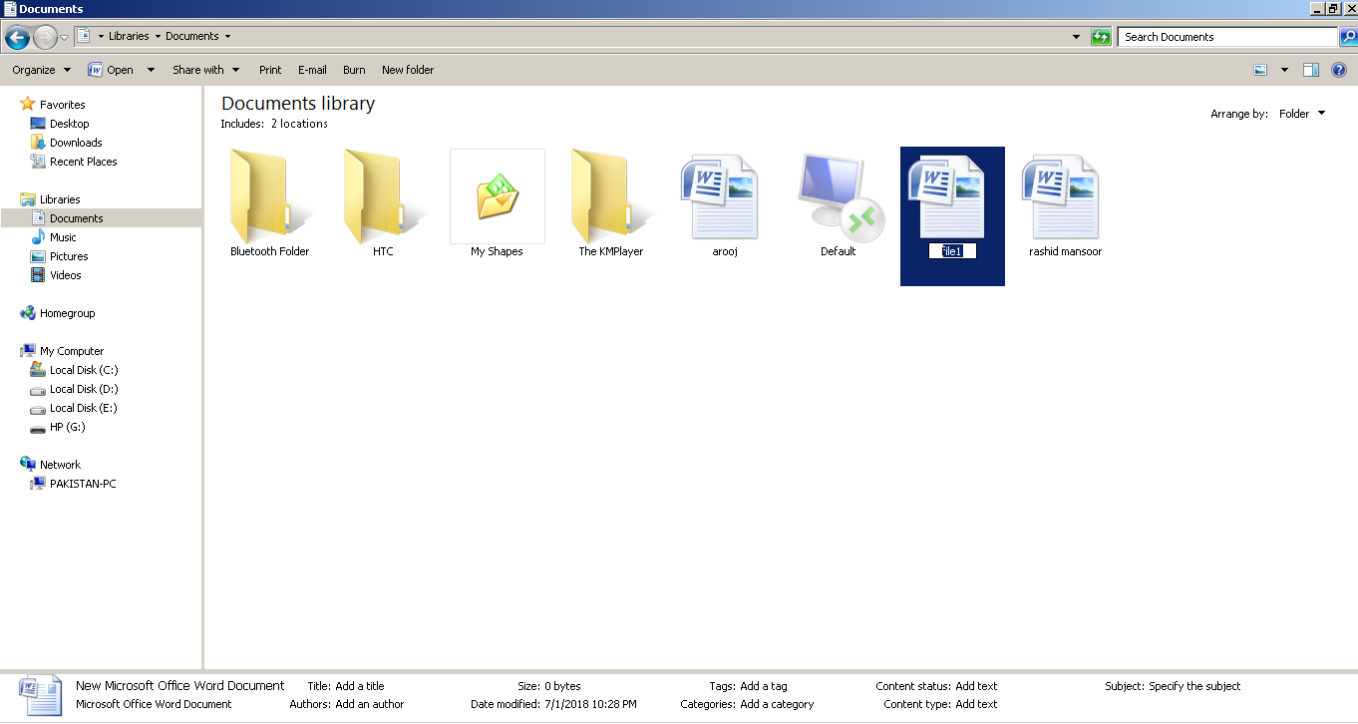

Figure 4.1 (g) New file created

Activity 2

In the folder named as *Activity 1*, create a word file

named as *activity2*



### Copy/Move a File and Folder

**File**

* To copy a file, select the file you want to copy and right click on it
* A menu will appear. Select *copy* from that menu

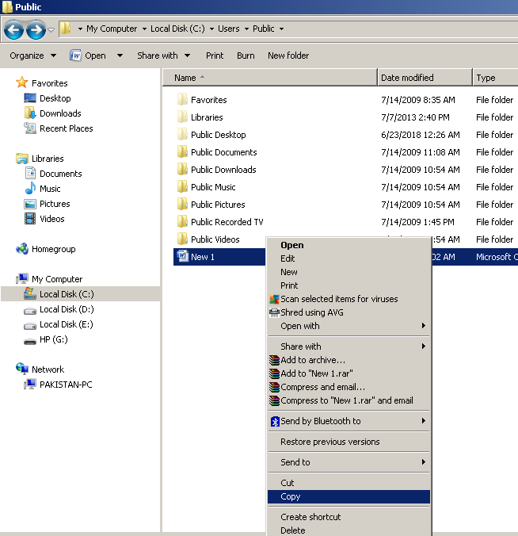

Figure 4.1 (h) copy file

* Navigate to the folder where you want to copy the file
* Right-click anywhere in the empty space of window and click on paste

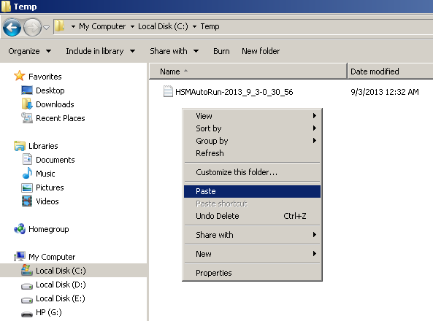

Figure 4.1 (i) paste file

* In windows 10 Microsoft has made it easier to copy and paste a file. To copy a file, select the file you want to copy and click *Copy to* under the Home tab.

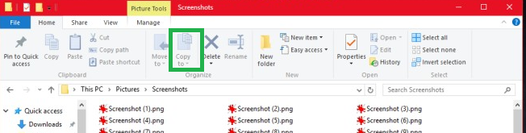

Figure 4.1 (j) copy file in Windows 10

* A drop down will open with recent locations. Choose the location if it’s listed, or click the Choose Location button and select the location.
* File will be pasted at your chosen location



Activity 3

In Drive D: create a new folder named as *Activity 3.* Copy

file *activity2* from folder *Activity 1* and paste it into the

folder *Activity 3.*

**Folder**

* Select the folder you want to copy
* Right-click and select c*opy*

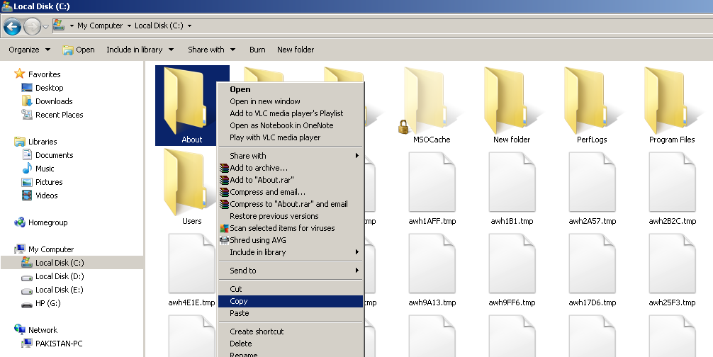

Figure 4.1 (k) copy folder

* Move to the location where you want to paste it. Here we will move our folder from drive C to drive D
* Right-click anywhere in the empty space and select *paste*
* Alternatively in Windows 10, choose *copy to* from *Home* tab and select the location where you want to move the selected folder.

### Cut/Paste a File and Folder

When *Cut* option is selected, the selected file/folder is deleted from the current location and moved to the new selected location as opposed to *copy* option where the file remains both in the original as well as new location.

TO cut and paste a file/folder simply follow all the steps for *copy and paste* discussed in the previous section but choose *cut* instead of *copy* option.

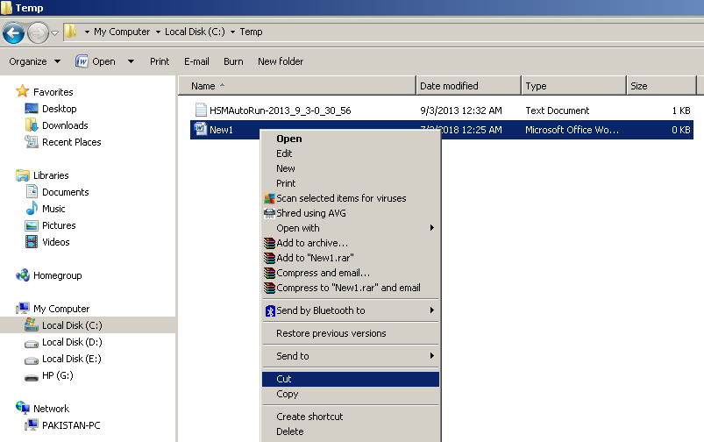

Figure 4.1 (l) cut file

And in Windows 10, select the option *move to* instead of *copy to*

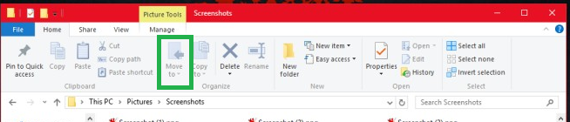

Figure 4.1 (m) Move to option in Windows 10

Activity 4

Cut folder *Activity 3* from drive D: and paste it in drive E:



### Delete a File and Folder

Method 1

* Select the file/folder that you want to delete
* Right-click and from the drop down menu select *delete*

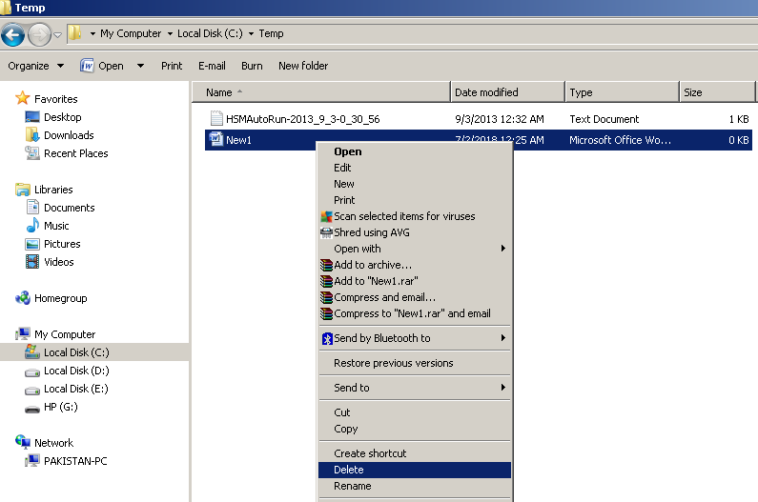

Figure 4.1 (n) Delete method 1

Method 2

* Click and Select the file/folder you want to delete
* Press *Delete* button on the keyboard

Method 3

* In windows 10, select the file/folder you want to delete
* Click on *delete* option in the Home tab

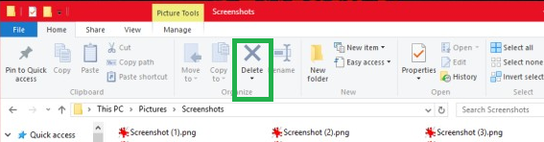

Figure 4.1 (o) Delete method 3

Activity 5

Delete folder *Activity 3* from drive E:



## Using Computer for Drawing

Microsoft Paint or MS Paint is a basic software included with all versions of Windows operating system. It can be used to draw, color and edit pictures and graphics. Users can also import pictures and edit them in Paint. MS Paint can open and save files in BMP, JPEG, GIF, PNG and TIFF formats.

DO YOU KNOW?

In July 2017, Microsoft added MS Paint to the list of deprecated programs meaning it won’t be developed further. It will, however, be available in the Windows Store for free



.

Opening MS Paint

To open MS Paint in Windows 10, follow these steps

* Click on Start Menu
* Click on All Apps
* Click on Windows Accessories folder
* Click on Paint
* Paint main interface is launched.

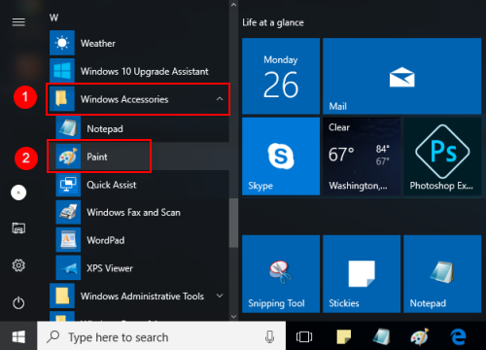

Figure 4.2 (a) Opening Paint

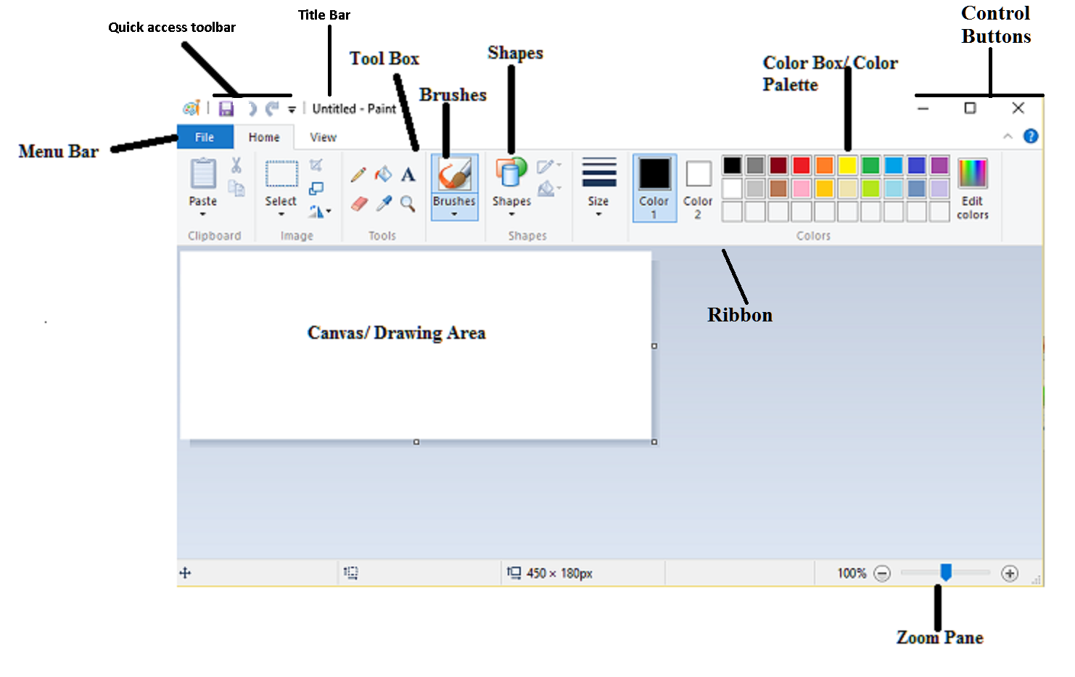**Figure 4.2(b) Paint Window**

Activity 6

You can also change the size of your canvas by using

*resize* button in the Home tab. Select “Pixels” and

type the desired size in the “horizontal” and “vertical” box

Or, if you’d rather adjust the size by percentage, select

“Percentage” and enter the percentage by which you’d

like to increase or decrease the current canvas size. For example,

to double the current size, type 200 into each box.



### 4.2.1 Menu bar, Tool box and Color Pallete

### Menu Bar

The Menu Bar is located under the title bar and consists of 3 tabs.

* **File**

It has options of New, Open, Save, Save As, Print, Set as Desktop Background, Properties, About and Exit.

* **Home**

Home tab Consists of the Clipboard, Image box, Tools Box, Brushes, Shapes and Color Palette.

* **View**

The View tab consists of the options of Zoom, Show/ Hide and Display.

### Tool Box

**Tool Box** in Paint consists of 6 Main tools for drawing and coloring images.

* **Pencil**

With the pencil tool, you can draw a free form line or drawing with the selected line width.

* **Fill With Color**

Fill with color tool is used to fill desired color in the selected area of the image. Click an area on the canvas to fill it with the foreground color or right click to fill it with the background color.

* **Text**

It is used to insert text into the picture.

* **Eraser**

It works like a typical eraser. Eraser can be used to erase parts of the picture which will reveal the background color.

* **Color Picker**

This tool can be used for picking a specific color from any part of the picture and using it in the drawing.

* **Magnifier**

It can be used to change the magnification or zoom level of a part of the picture

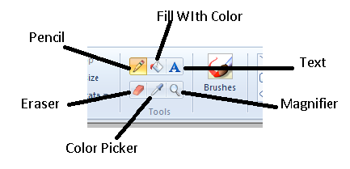

Figure 4.2.1 (a) Tool Box

Activity 7

|  |  |
| --- | --- |
| Free form drawing |  |
| Fill desired color |  |
| Insert text |  |
| Erase parts of picture |  |
| Picking a specific color |  |
| Change zoom level of the picture |  |

**Write names of tools in front of related functionality**

### Color Palette

The collection of colorful boxes at the top right of paint window is known as the **color palette**. Clicking on a color will select it as the **foreground color** which is shown by the box labeled as Color 1 on the left side of the color palette. Whenever a paint tool such as pencil, line, brush or eraser is used, it uses the Color 1 settings. For selecting a **background color** simply click on the box labeled as Color 2 and select a color from color palette. The background color is used as a fill whenever a closed object like circle, rectangle etc is drawn or to fill a deleted area of the image. The Edit Color option on the right side of the palette allows users to customize shades according to their desire.

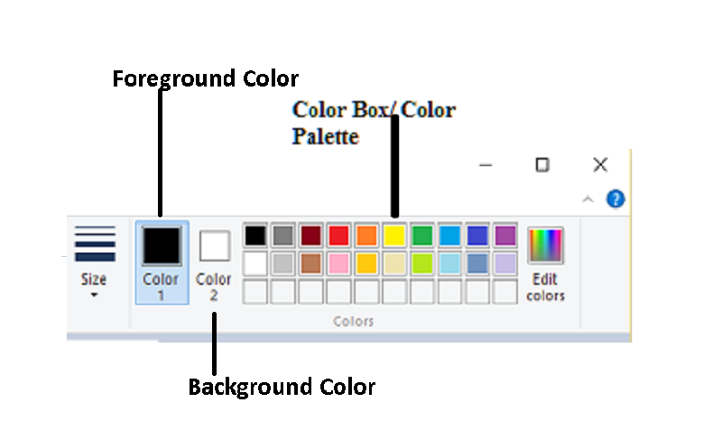

Figure 4.2.1 (b) Color Palette

### 4.2.2 Using the Pencil Tool

**Pencil tool** is much like an actual pencil. It is used for drawing freehand shapes of desired line thickness. To draw with pencil, select the pencil tool from the tool box and select your desired thickness from the Size option. Now place your mouse cursor over the canvas and press the left mouse button as you drag it along the screen. This will draw a line in the foreground color. To draw in background color, simply repeat the process with right mouse button. Fig. 4.2.2 shows lines of various thicknesses and freehand shapes drawn with pencil tool.

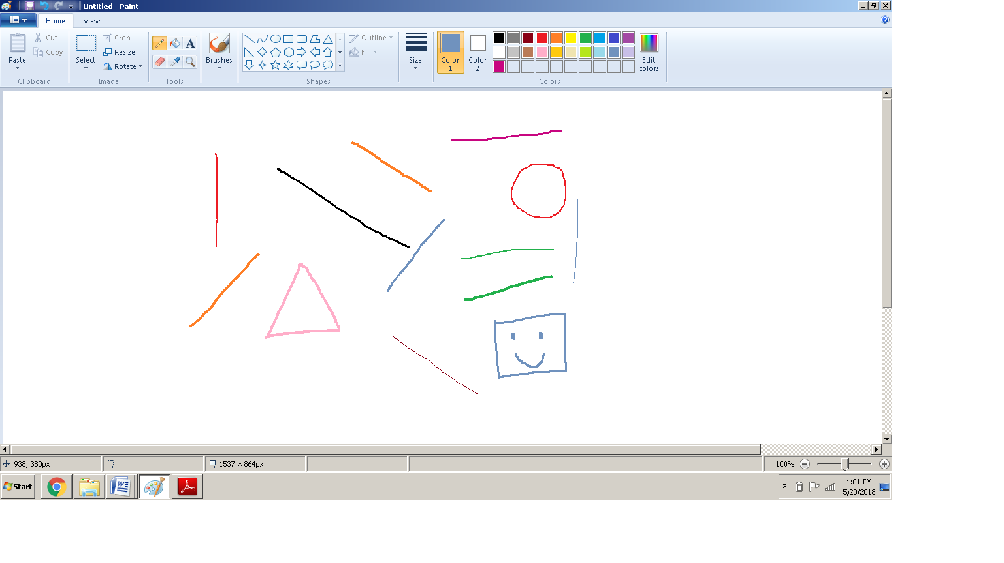

Figure 4.2.2 Pencil Tool



Activity 8

* Select different color for foreground and background

colors.

* Use *fill with color* tool to fill canvas first with

foreground color and then with the background

color.

* Use pencil tool to draw freehand shapes and lines on the canvas

### 4.2.3 Tools to draw and color

### Using Brushes

**Brushes** are more versatile than the typical pencil as you can use different brush tips to create different types of strokes. Clicking on the Brushes tab will reveal 9 different types of brush tips. Their thickness can also be selected from the Size tab.

* **Brush**

Brush renders a brush with a solid fully opaque color.

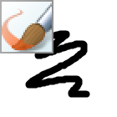

* **Calligraphy Brush 1**

Calligraphy Brush 1 renders a brush that mimics use of a calligraphy pen.

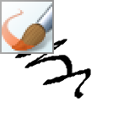

* **Calligraphy Brush 2**

Calligraphy Brush 2 renders a brush that mimics use of a calligraphy pen that is slightly different from calligraphy brush 1.

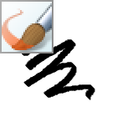

* **Airbrush**

Airbrush mimics the use of an actual airbrush.

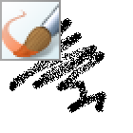

* **Oil Brush**

Oil Brush creates strokes similar to that used to create an oil painting.

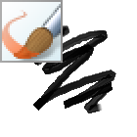

* **Crayon**

Crayon renders a brush that’s mimics the use of a crayon.

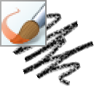

* **Marker**

Marker renders a brush that mimics the use of a marker.



* **Natural Pencil**

Natural Pencil renders a brush that gives result similar to a natural pencil.

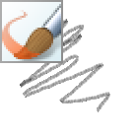

* **Watercolor Brush**

Watercolor brush is used to create strokes similar to that used to create a watercolor painting.

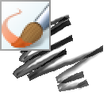

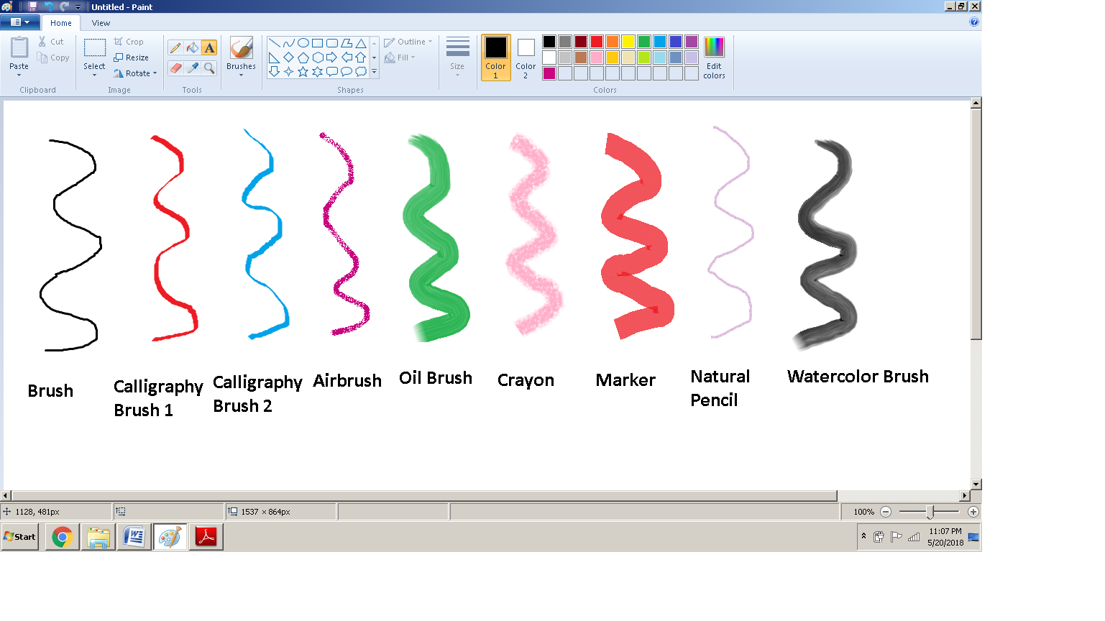

Figure 4.2.3 (a) Brushes

Activity 9

Make a drawing in MS Paint using all the brushes discussed

above



### Using Shapes

**Shapes** tab offers a wide variety of different shapes that can be drawn on the canvas. The **outline** option is used to draw different types of outlines of the selected shape. The options available are No Outline, Solid Color, Crayon, Marker, Oil, Natural Pencil and Watercolor. The **fill** option is used to fill the selected shape with desired brush strokes of selected color. It has options of No Fill, Solid Color, Crayon, Marker, Oil, Natural Pencil and Watercolor.

To draw a shape, select that shape from the Shapes tab and then choose your preferred outline and fill options. Hold down the left mouse button and drag the mouse across the canvas. Release the mouse when you reach the desired shape size. If you have selected an option other than No Outline, the shape will have an outline in Color 1 and if you have selected an option other than No Fill the shape will be filled with Color 2.

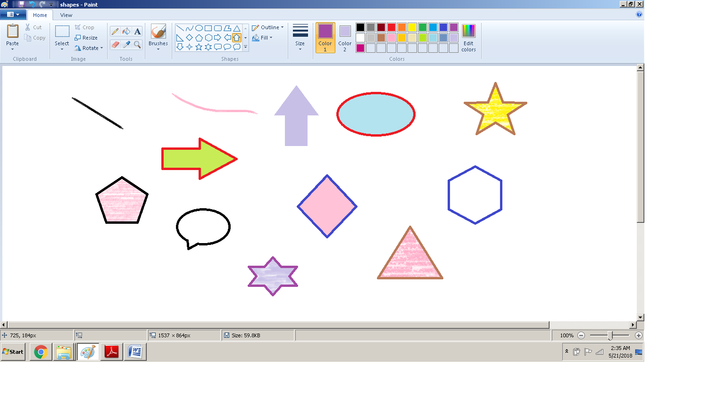

**Figure 4.2.3 (b) Shapes**

Activity 10

Using the tools discussed above, try to draw a simple bear.



|  |  |
| --- | --- |
| **1**. wpe1.jpg (4406 bytes) | **2**. wpe5.jpg (5108 bytes) |
| wpe7.jpg (6607 bytes)  **3** | wpeA.jpg (6169 bytes)  **4** |
| wpeD.jpg (6888 bytes)  **5** | wpeF.jpg (7476 bytes)  **6** |

### 4.2.4 Copy/ Paste and Modify an Image

* Select the Fill with Color tool and fill the canvas with green color.
* Select six-point star from the Shapes tab and draw by dragging mouse over the canvas. For drawing a red shape, select solid fill from the fill tab and select red color as Color 2.
* Select oval from Shapes and select black color as Color 2. Draw a small black oval in the centre of star to make it a flower.
* Using curve tool from Shapes, draw stem of the flower.

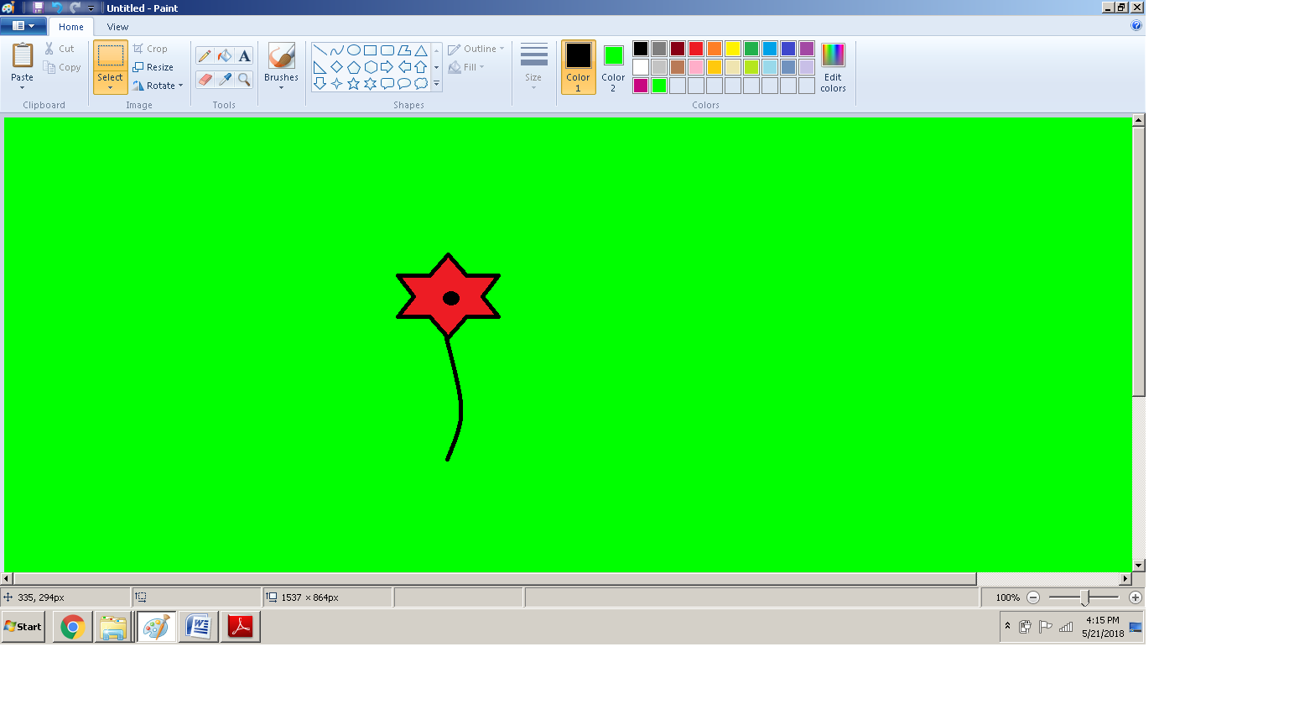

**Figure 4.2.4 (a) Drawing a flower**

* Now click on the Select tool and select the whole flower by dragging the mouse to draw a rectangle around it.
* Click on the Copy option located on the top left corner of Ribbon, in the clipboard tab.
* Click on Paste located beside copy option in the clipboard tab.

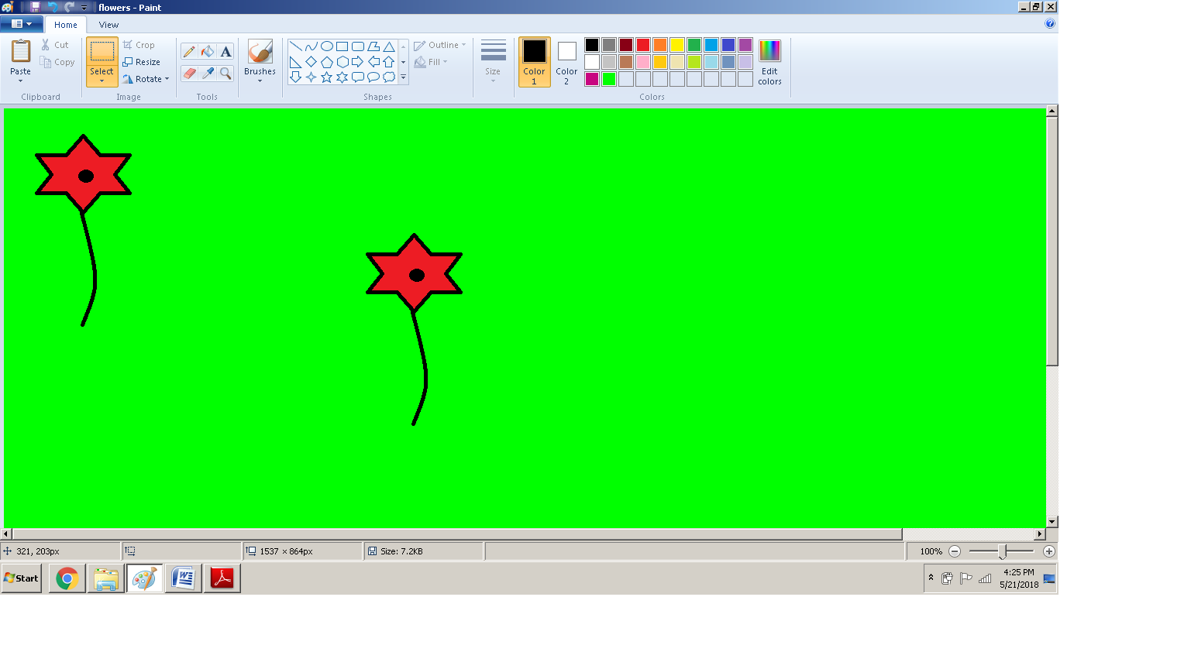

**Figure 4.2.4 (b) Copy/ Pasting the flower**

* Select the newly pasted flower and drag it to a new location on canvas.
* Select any color of your choice as Color 1 and use Fill with Color to fill the pasted flower with that color.

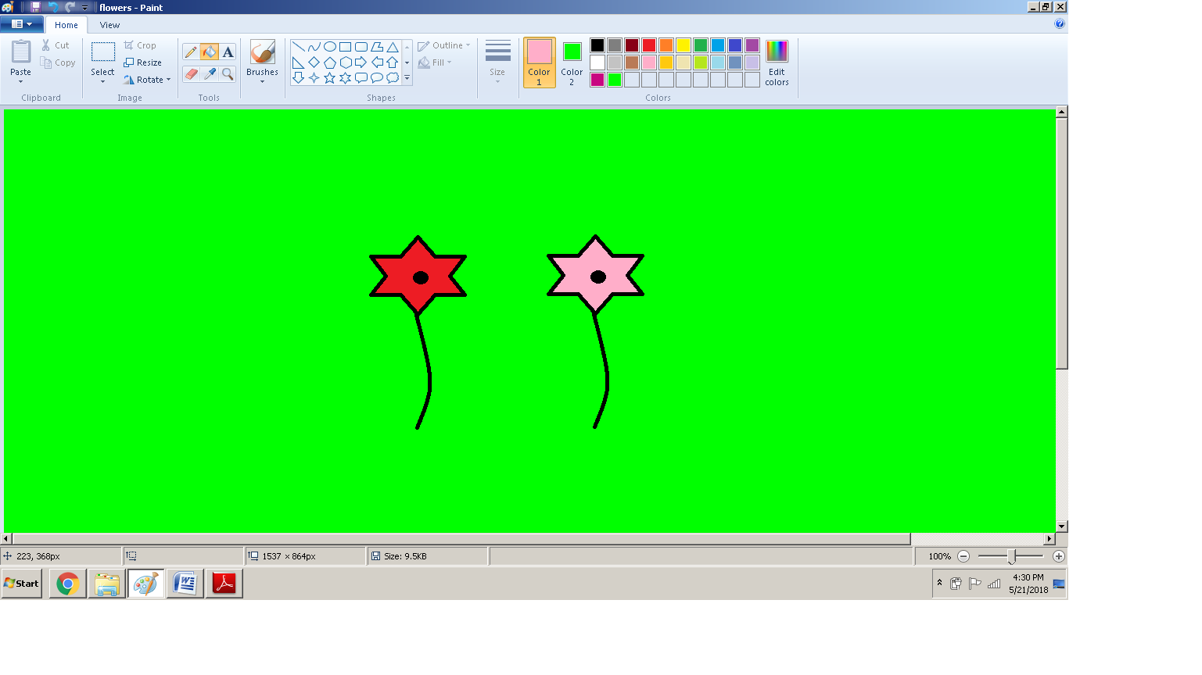

**Figure 4.2.4 (c) Changing the color of flower**

* Repeat above mentioned steps to draw several colorful flowers on the canvas.
* Select oval from Shapes. Select black color as Color1 and dark green as Color 2.
* Draw small ovals as leaves of the newly pasted flowers.
* Using the Text tool write Flowers on the top.

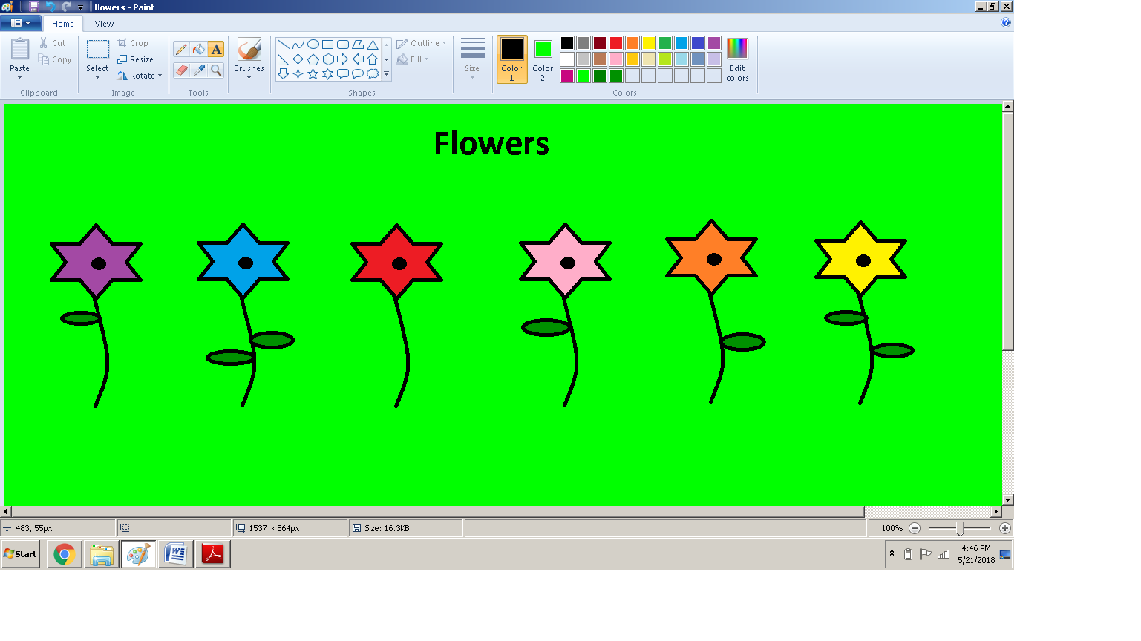

**Figure 4.2.4 (d) Adding leaves and text**

Activity 11

Draw a night time sky with a moon and lots of stars. Draw

and color one star and then copy and paste it several times

to fill the sky with stars.



* Resize, Skew, Rotate and Invert the Image
* Select the purple flower and click on Resize option in the Image tab.
* The Resize and Skew window will open. In the Resize area, type 50 in the horizontal and vertical windows and click okay. This will reduce the size of selected flower by 50%.

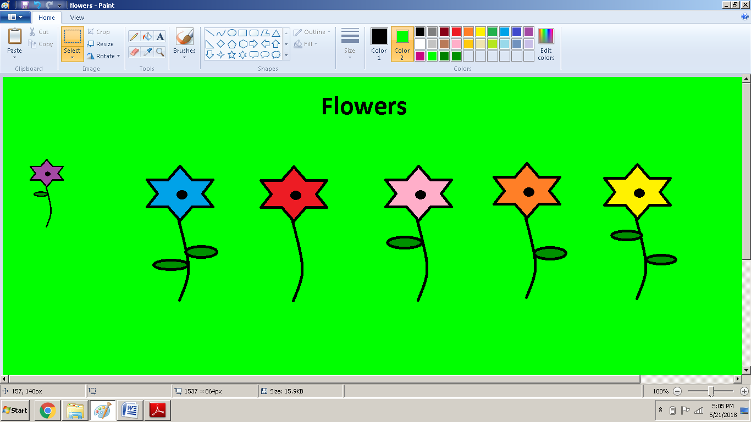

**Figure 4.2.4 (e) Resizing the flower**

* To skew the image, repeat the above mentioned steps and type 45 in the horizontal window in the Skew section.

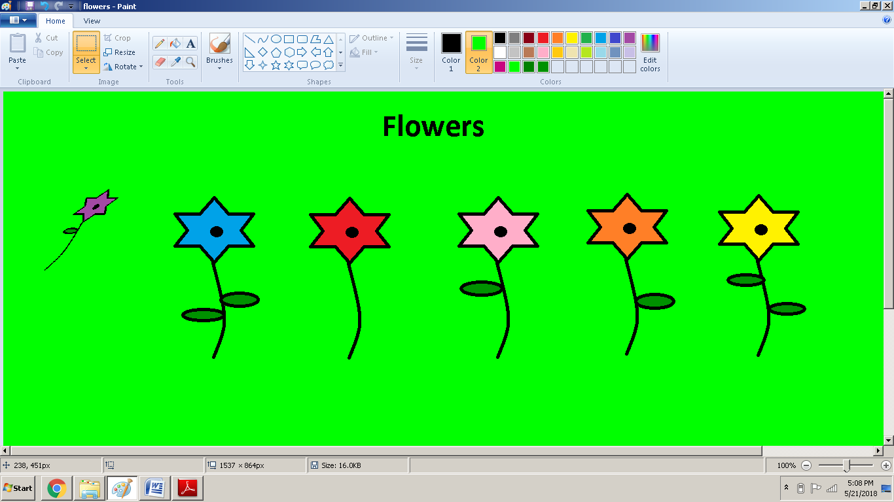

**Figure 4.2.4 (f) Skewing the flower**

* To rotate, select the blue flower and click on Rotate option in the Image tab.
* A drop down menu will appear. Select *rotate right 90.*

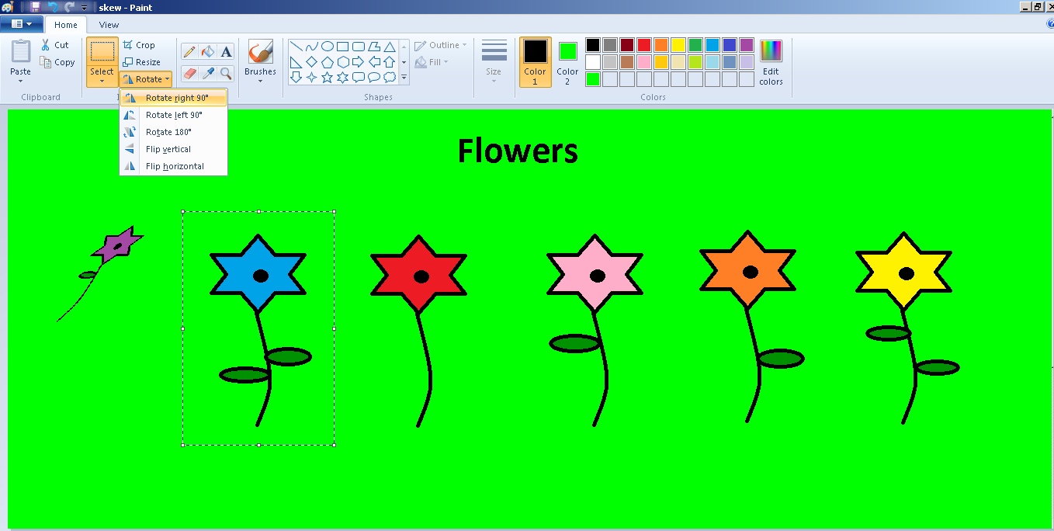

**Figure 4.2.4 (g) Rotate right 90**

* The flower will be rotated at 90 degrees

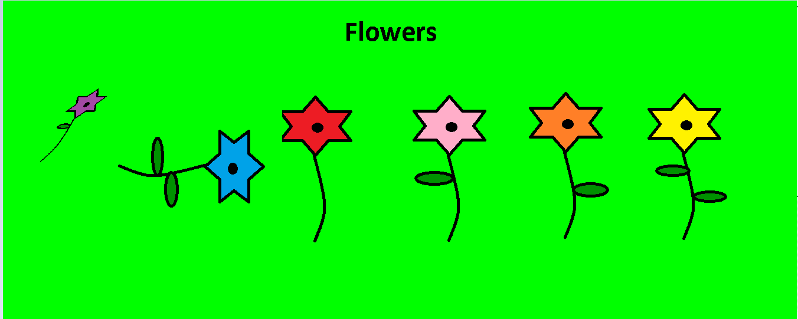

**Figure 4.2.4 (h) Rotate flower**

* To invert, follow the above mentioned steps but select *flip horizontal*

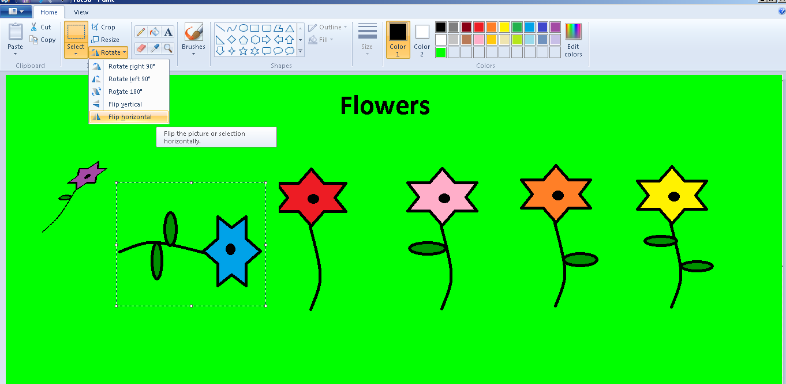

**Figure 4.2.4 (i) invert flower**

* The artwork will invert its direction

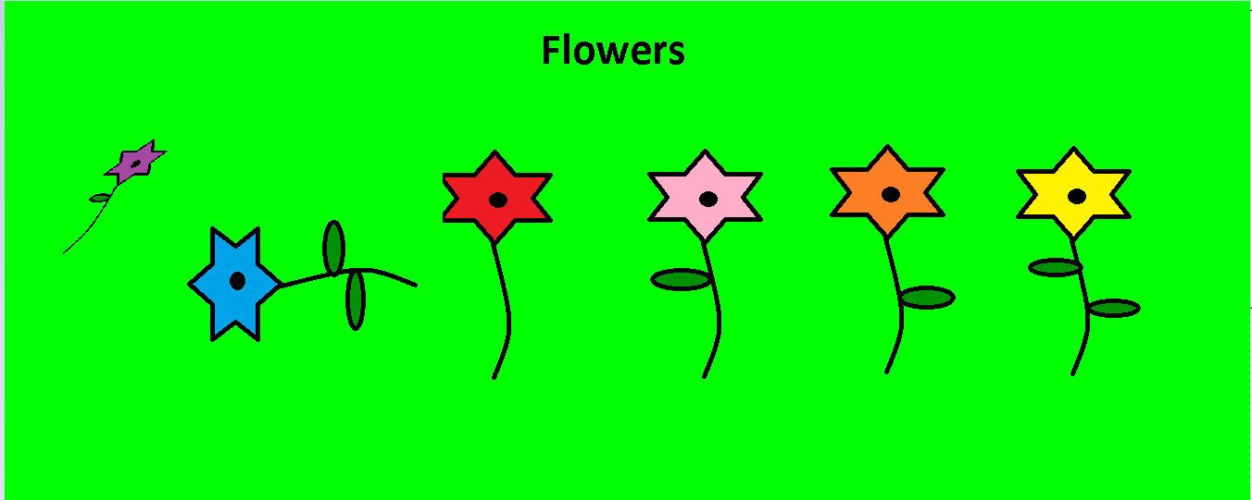

**Figure 4.2.4 (j) Inverted flower**

* Now using the eraser tool, erase the skewed and inverted flowers. Note that while erasing some unwanted details from the drawing, the color used in canvas which in this case is light green must be selected as Color2 as Color2 is used to fill the space revealed after erasing something. You can also delete the flower by selecting it and pressing Delete on the keyboard.

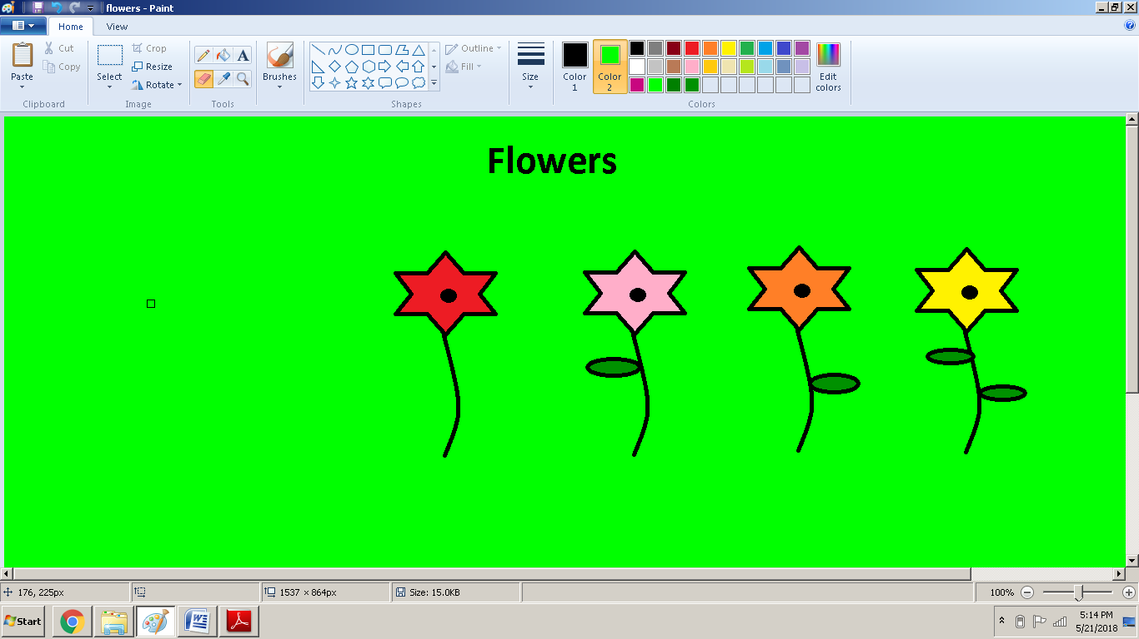

**Figure 4.2.4 (k) Erasing unwanted details**

Activity 12

Resize, skew, invert and rotate several stars to have different

types of stars in your drawing. Erase the ones that seem odd

or unfitting.



### 4.2.5 Save File

* To save your file click on the File or the Paint button. You can also click the floppy disk image on quick access toolbar to save your file.
* It will drop down the list which has option of Save and Save As. Click on Save. Alternatively you can also press cltr + s. This will open the Save As dialogue box.
* Click on the folder where you want to save your file.
* Write the name of your file
* Click Save.

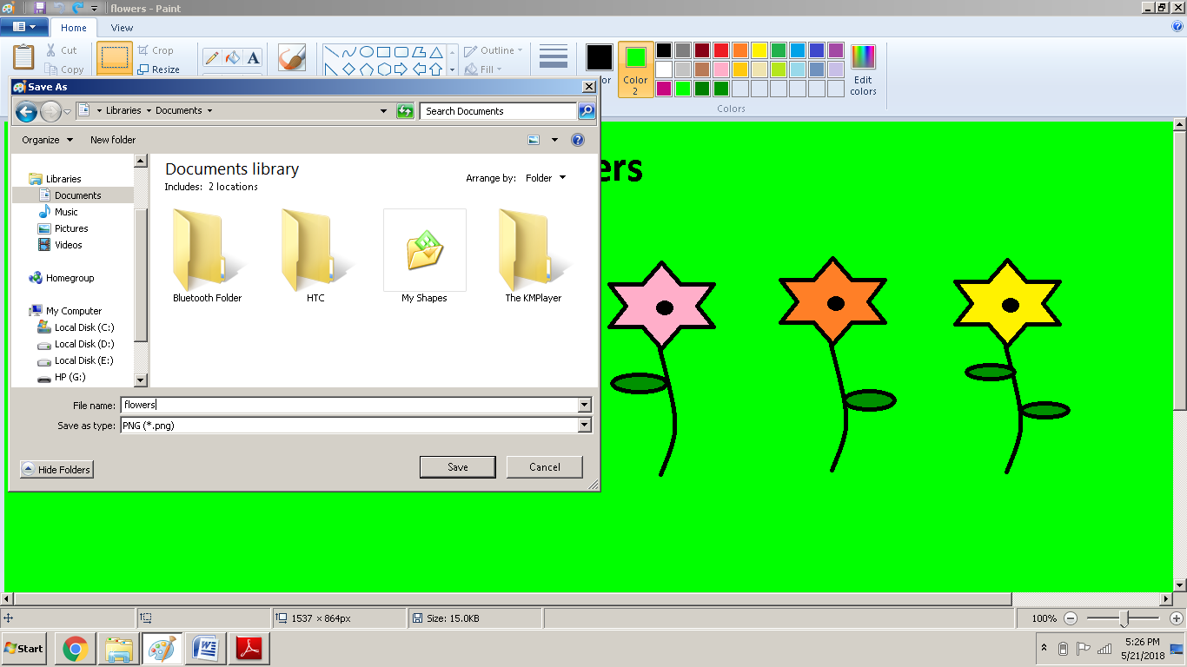

**Figure 4.2.5 Save As dialogue box**

Activity 13

Save your drawing with name “*night time sky”*



# 4.3 Using Computer to Write a Document

**Word Processing** means to create, edit and print documents using a software on a computer. The software used to produce text documents on a computer is called a **word processor.**

**Microsoft Word** or **MS Word** is the most widely used word processor and Word 2016 is its latest version. **Microsoft Word 2016** is a word processing application that allows you to create a variety of documents, including letters, resumes, and more.

DO YOU KNOW?

While doing word processing, words are known as ‘text’ and the whole text is called a ‘document’

.

Opening MS Word

* Click Start.
* Click on Word icon. G:\PTBB\word\icon.png
* The Word 2016 opens up to the main screen.

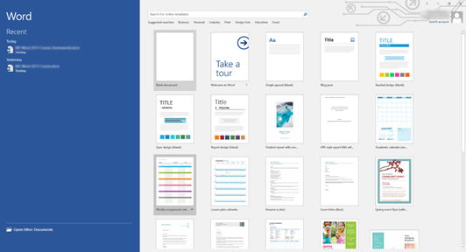

**Figure 4.3 (a) Word 2016 start screen**

**Creating New Document**

To create a new blank document, follow these steps

* Select the File tab to access Backstage view.

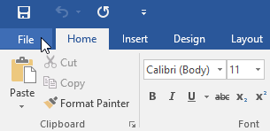

**Figure 4.3 (b) Select File tab**

* Select New, then click Blank document.

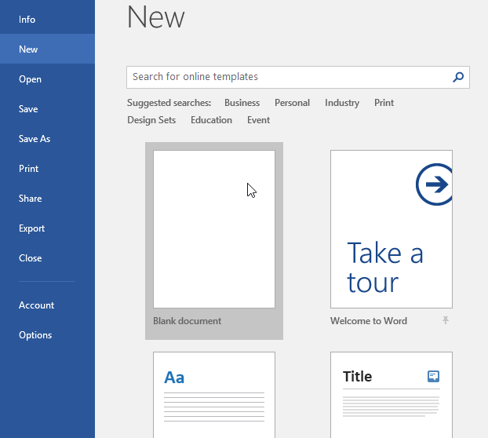

**Figure 4.3 (c) The backstage view**

* A new blank document will appear.   A blank Word document is just a white, blank area. It doesn't have any formatting or dummy text added to it as a template might.

In previous versions of Ms Word, new document can be created using the **Microsoft office button**

* Click the Microsoft Office button.

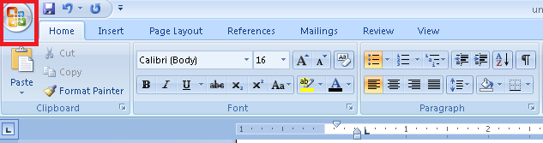

**Figure 4.3 (d) Microsoft office button**

* Select New. The New Document dialog box appears.
* Select Blank document under the Blank and recent section. It will be highlighted by default.

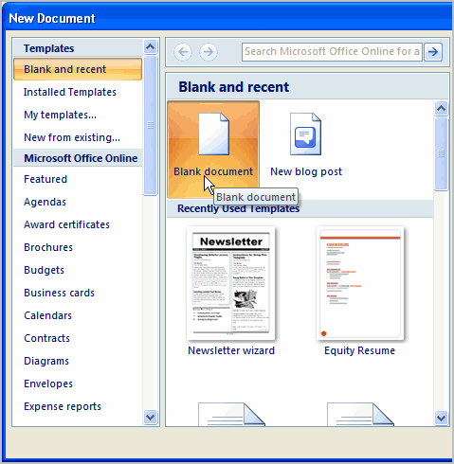

**Figure 4.3 (e) Blank document**

* Click Create. A new blank document appears in the Word window.

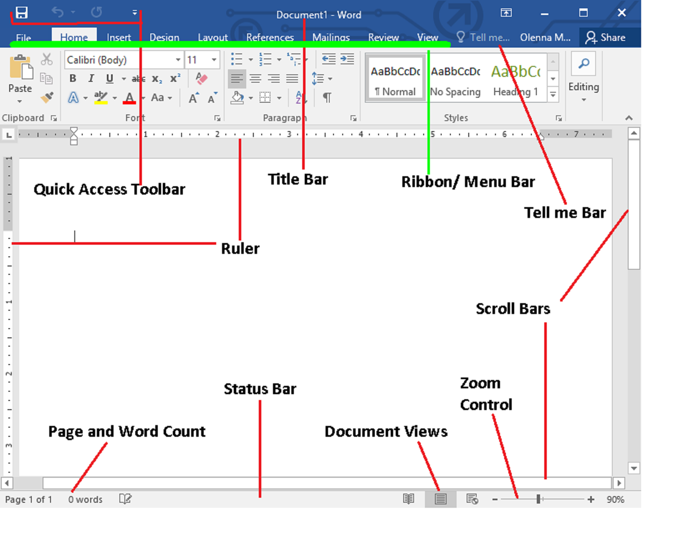

**Figure 4.3 (f) Word 2016 main screen**

**Quick Access Toolbar**

It lets you access common commands no matter which tab are selected. By default, it includes the **Save**, **Undo**, and **Redo** commands.

**Ribbon / Menubar**

The **Ribbon** contains all of the commands you will need to perform common tasks in Word. It has multiple tabs, each with several groups of commands.

The ribbon is divided into seven tabs and each tab is a collection of several groups that show related items together:

* **Tab** is a collection of several groups of related commands.
* **Groups** show similar commands together.
* **Dialogue Box Launcher** gives access to additional commands
* **Command Buttons** are used to issue commands or to access menus and dialogue boxes.

**The Ruler**

The **Ruler** is located at the top and to the left of your document. It makes it easier to make alignment and spacing adjustments.

**Page and Word Count**

From here, you can quickly see the number of **words** and **pages** in your document.

**Tell me**

The **Tell me** bar allows you to search for commands, which is especially helpful if you don't remember where to find a specific command.

Activity 14

* In the *Tell me bar* type *Shape* and press Enter.
* Choose any shape from the menu and Double-

Click somewhere on your document.

* You can also open *shapes* command from *Insert*

Tab in the *Illustrations* group

* Zoom the document to 120%
* Change the *Document View* to *Web Layout*



**Text Editing**

Adding, deleting and re-arranging text in the document is called **text editing.**

* **Typing Text into the Document**

A flashing vertical line on the screen is called **cursor** or **insertion point**. The text we type will appear where the insertion point flashes on the screen.

As we type, the insertion pointer moves horizontally towards the right of the screen. When we reach the end of a line, Word automatically wraps the text to the next line.

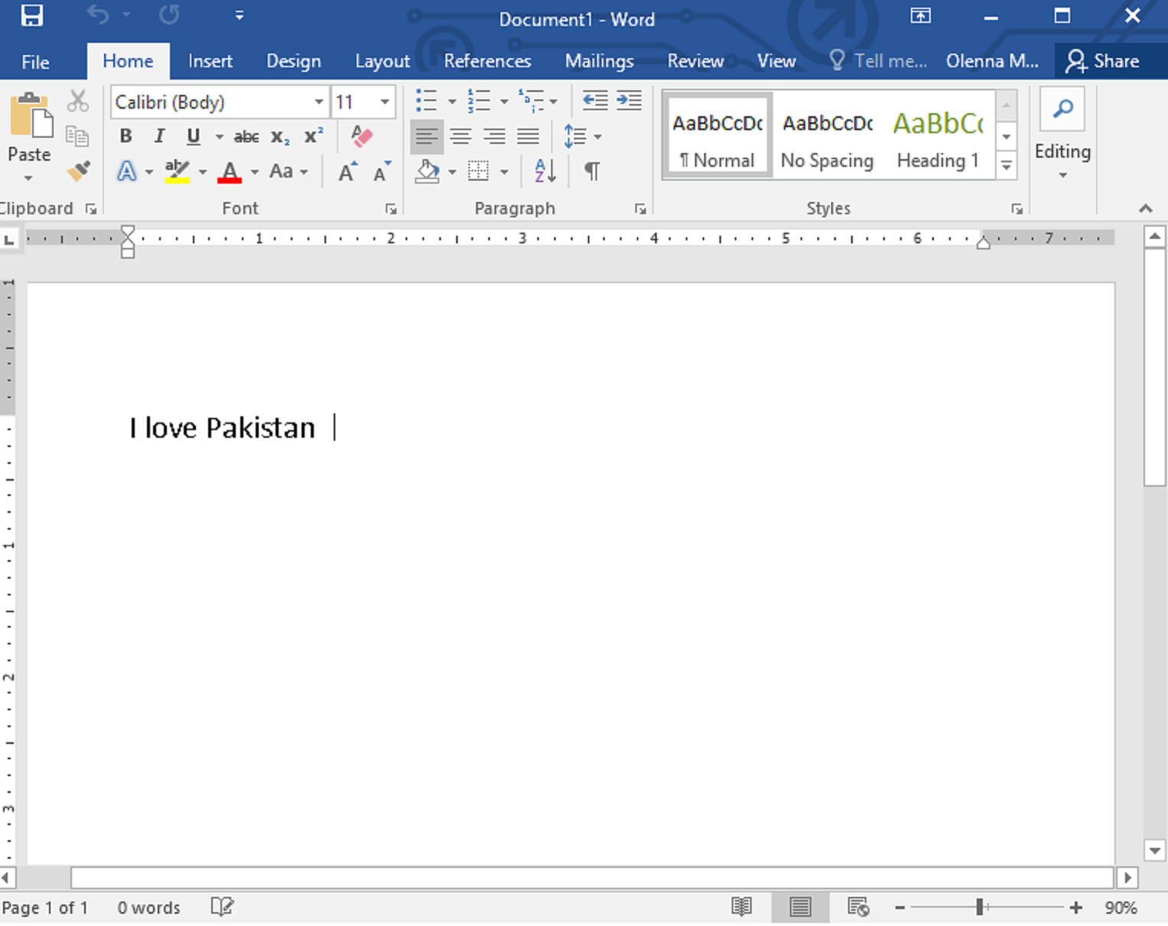

**Figure 4.3 (g) Typing text in Word 2016**

Activity 15

Type the paragraph after “*Typing text into the*

*Document”* heading in a word document.



* **Select Text**

Before using any Word feature, a user must first **select** the required text. Selected text appears highlighted on the screen.

How to Select Text?

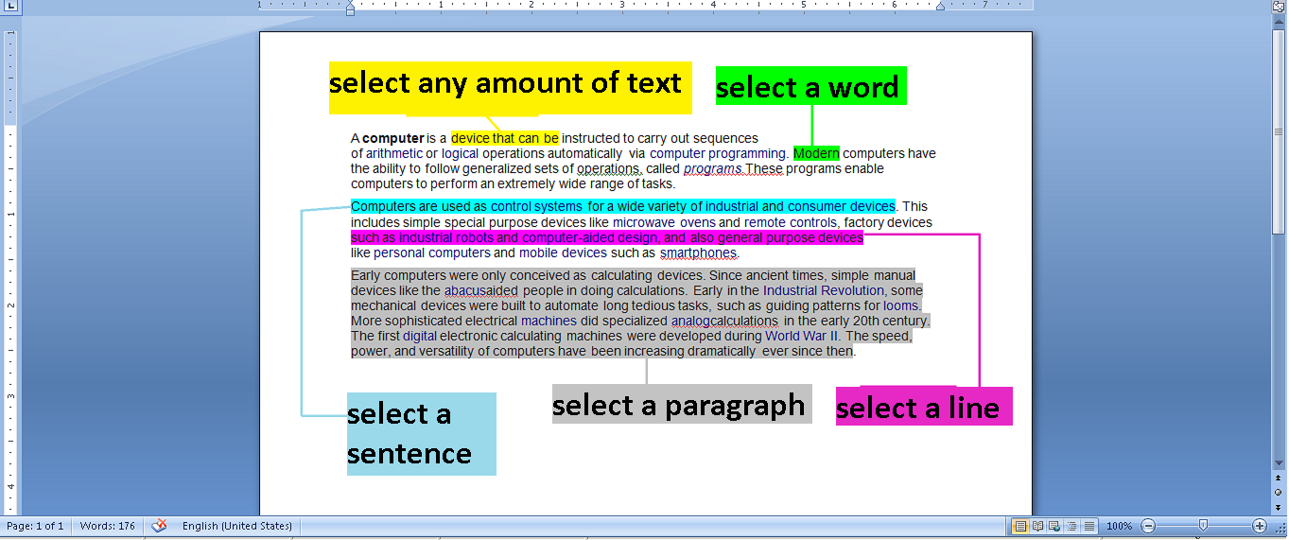 **Figure 4.3 (h) Selecting text**

* **Select any amount of text**

Just drag the mouse pointer over the text while holding down left mouse click or hold the shift key and press arrow keys.

* **Select a word**

Move the mouse anywhere over the word you want to select and double click the word

* **Select a sentence**

Hold down the control key and then click anywhere in the sentence.

* **Select a line**

Move the mouse towards left of the line until it changes to a right-pointing arrow and then click.

* **Select a paragraph**

Move the mouse to the left of a paragraph until it changes to a right- pointing arrow and then double click.

* **Select entire document**

Move the mouse pointer to the left of paragraph until it changes to a right-pointing arrow and then triple click. Alternatively press Ctrl + A.

Activity 16

Type the paragraph written under “*Using Shapes”* heading

in the previous topic. In that text, select any line, sentence,

a word and a paragraph and make them bold using the **B**

button in the Font group.



DO YOU KNOW?

You can also select text with the keyboard by:

* Holding the *Shift keys* while using the arrow keys to expand the highlight
* Holding the Ctrl + *Shift* keys while using arrow keys to select word by word.



.

* **Cut/ Copy / Paste Text**

The **copy command** creates a duplicate of the selected text, leaving the original text unchanged. The **paste command** pastes the copied text at the insertion point. When we copy and paste the text, it appears in both original and new location.

* Select the text and click the copy option in the clipboard tab at top left corner or press Ctrl + C.

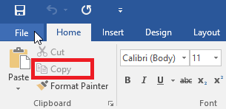

**Figure 4.3 (i) Copying text**

* Move the cursor where text has to be pasted and click on the paste option beside copy button or press Ctrl + V.

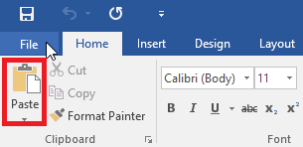

**Figure 4.3 (j) Pasting text**

A user can move text from one position to another in a document using the cut and paste commands. The **Cut** command deletes the selected text from its original location. The paste command then places this text at the insertion point.

* Select the text and click the Cut option in the clipboard tab or press Ctrl + X.

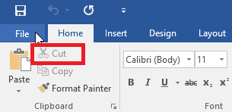

**Figure 4.3 (k) Cutting text**

* Move the cursor where text is to be placed and click the paste button or press Ctrl + V.

Activity 17

* Make a list of provinces of Pakistan (Sindh, Balochistan,

Khyberpakhtoon Khawa, Punjab)

* Copy and paste a duplicate of this list.
* Now cut and paste the names of provinces such as the most

populated province comes first.



* **Deleting Text**

Removing text from a document is known as **deleting.** A user can remove unwanted text from document by following methods:

* **To delete a single character**

Place the cursor to the right of character and press the backspace key.

* **To delete a block of text**

Select the text and press Delete key.

* **Fonts**

**Text formatting** allows you to change the appearance and layout of text and other characters within a document. The **font** determines the way your text appears on your screen and when you print the document. There are more than several different types of font. The more common types are Times New Roman, Calibri and Verdana. You can apply a font to either an entire document or to certain portions of a document.

Changing Font Style

* To apply a font, click on the Home tab and go to the Font group.

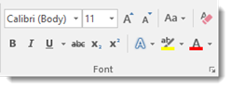

**Figure 4.3 (l) Fonts**

* The current type of font is Calibri. You can click on the downward arrow in that window to display other types of fonts available to use.
* To change the type of font within a document or for the entire document, simply select the text to be formatted and select a new font.

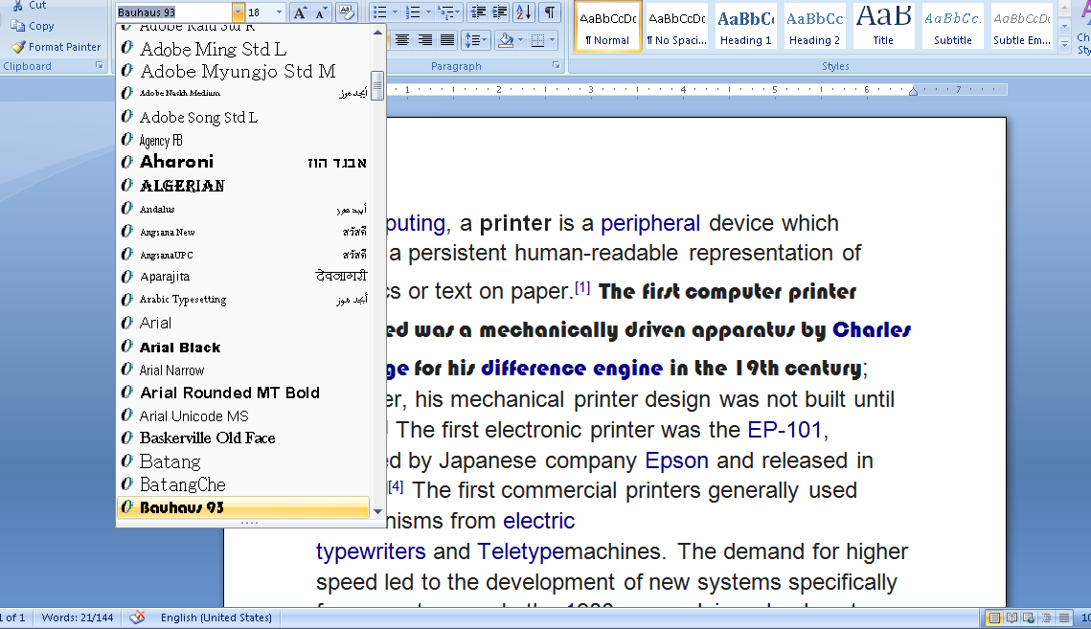

**Figure 4.3 (m) Changing Font Style**

* To change the font of color, select the font to be changed and select a color by clicking on the drop down arrow beside **A** button in the Font group.

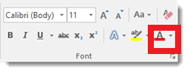

**Figure 4.3 (n) Changing Font Color**

Changing Font Size

In addition to changing the type of font, you can also change the font size. Next to the type of font under the Home tab is a box that states the size of font currently being used. Our current font size is 11.

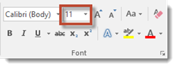

**Figure 4.3 (o) Font Size**



Activity 18

* Write your complete name in a document example Ali Usman.
* Copy and paste it two times and press enter after each name.

Ali Usman

Ali Usman

Ali Usman

* Select the first line and click the button ***B***in the *font* group.
* Select the second line and click the button ***I***in the *font*

group.

* Select the third line and click the button ***U***in the *font* group.
* You should see something like this

**Ali Usman**

*Ali Usman*

Ali Usman

* Choose a different *font size* and *font style* for each line

To change the size of the font, simply select the text that you want to be changed.

* Select the new font size. You can change an entire document or just a portion.
* You can also use the two uppercase A's beside the font size box to change the size of fonts you're currently using. Clicking the larger A will increase your font size by one for each time it's clicked. On the other hand, clicking the smaller A will decrease the font size by one for each time it's clicked.

Changing Font Alignment

**Alignment** determines the appearance and orientation of the edges of the paragraph. Alignment of text can be changed by using alignment buttons in the paragraph group on the ribbon.

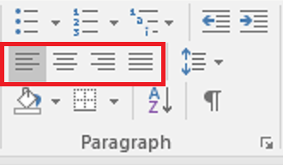

**Figure 4.3 (p) Font Alignment**

* **Left Align G:\PTBB\word\al.gif**

It aligns text at the left margin. This is the default setting.

* **Center G:\PTBB\word\cent.gif**

The text is centralized. It can be used in a card or an envelope and in a listing.

* **Right Align G:\PTBB\word\ar.gif**

It aligns text at the right margin. This can be used for addresses.

* **Justify G:\PTBB\word\just.gif**

It aligns text to both left and right margins, adding extra space between words as necessary. This creates a clean look along the left and right side of the page.



Activity 19

* Write a short poem

“Early to Bed

And early to rise

Makes a man

Healthy and wise”

* Press Ctrl + A to select all text
* In the *paragraph* group, click on each *Align* icon one by one

to see new layouts

* **Changing the Case of Text**

We can change the selected text to UPPERCASE, lowercase or other cases.

* Select the text that you want to format.
* Click the Change Case option in the Font group.
* A drop down menu will be opened with options for changing case of the selected text.

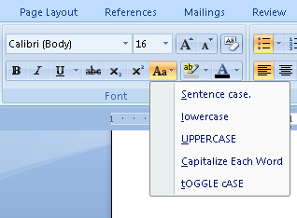

**Figure 4.3 (q) Change Case**

* Select an option. Your text will be formatted according to the selected option.
* **Sentence case**

First character in the sentence is in uppercase and the rest are in lower case.

* **Lowercase**

All characters are in lowercase (small letters)

* **UPPERCASE**

All characters are in uppercase (capital letters)

* **Capitalize Each Word**

First letter of each word of selected text is capital and rest is small.

* **tOGGLE cASE**

First letter of each word is small and rest is capital.

Activity 20

* Write your name in a new document. Example “Ali Ahmed”
* Select you name.
* On the *Home* tab, in the *Font* group, click on *Change Case*

option.

* Select “UPPERCASE” from the drop down menu.
* Your name will change to “ALI AHMED”
* Now try using all other options.



* **Check Spellings and Grammar**

Automatic Spellings and Grammar Check

By default, Word automatically checks your document for spelling and grammar errors, so you may not even need to run a separate check. These errors are indicated by colored wavy lines. The red line indicates a misspelled word. The blue line indicates a grammatical error, including misused words.



**Figure 4.3 (r) Spellings and grammar errors**

* To correct spelling errors
* Right-click the underlined word, then select the correct spelling from the list of suggestions. The corrected word will appear in the document. 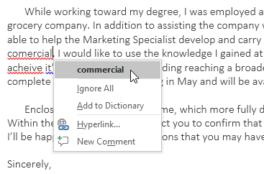

**Figure 4.3 (s) Correcting spelling errors**

* To correct grammatical errors
* Right-click the underlined word or phrase, then select the correct spelling or phrase from the list of suggestions. The corrected phrase will appear in the document.

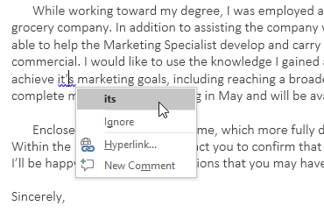

**Figure 4.3 (t) Correcting grammar errors**

To Run a Spellings and Grammar Check

* From the Review tab, click the Spelling & Grammar command.

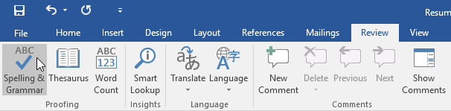

**Figure 4.3 (u) Spelling and grammar check**

* The Spelling and Grammar pane will appear on the right. For each error in your document, Word will try to offer one or more suggestions. You can select a suggestion and click Change to correct the error.

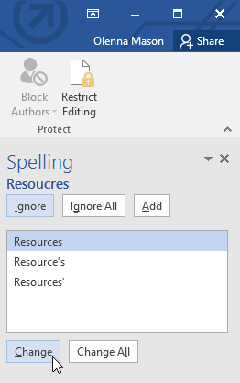

**Figure 4.3 (v) Spellings check**

* Word will move through each error until you have reviewed all of them. After the last error has been reviewed, a dialog box will appear confirming that the spelling and grammar check is complete. Click OK.

#### For spelling errors

* **Ignore**: This will skip the word without changing it.
* **Ignore All**: This
* will skip the word without changing it, and it will also skip all other instances of the word in the document.
* **Add**: This adds the word to the dictionary so it will never come up as an error. Make sure the word is spelled correctly before choosing this option.

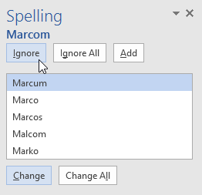

**Figure 4.3 (w) Ignore, Ignore All, Add**

Activity 21

* Again type the paragraph written under *Using Shapes*

heading but intentionally write wrong spellings of a few

words.

* Run a *spellings and grammar check.*
* Correct spellings and grammar errors.



* **Saving a Document**

It is important to save your documentwhenever you start a new project or make changes to an existing one. Saving early and often can prevent your work from being lost. You will also need to pay close attention to where you save the document so it will be easy to find later.

Word offers two ways to save a file: **Save** and **Save As**. These options work in similar ways, with a few important differences.

* **Save:** When you create or edit a document, you will use the Save command to save your changes. When you save a file, you will only need to choose a file name and location the first time. After that, you can click the Save command to save it with the same name and location.
* **Save As**: You will use this command to create a copy of a document while keeping the original. When you use Save As, you will need to choose a different name and/or location for the copied version.

To save the current document, follow these steps:

* Locate and select the Save command on the Quick Access Toolbar.

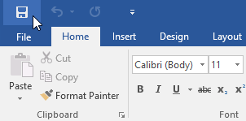

**Figure 4.3 (y) Select save command**

* If you are saving the file for the first time, the Save As pane will appear in Backstage view.

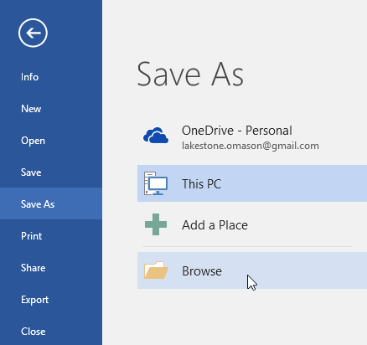

**Figure 4.3 (z) Save As**

* You will then need to choose where to save the file and give it a file name. Click Browse to select a location on your computer. Alternatively, you can click OneDrive to save the file to your OneDrive.
* The Save As dialog box will appear. Select the location where you want to save the document.

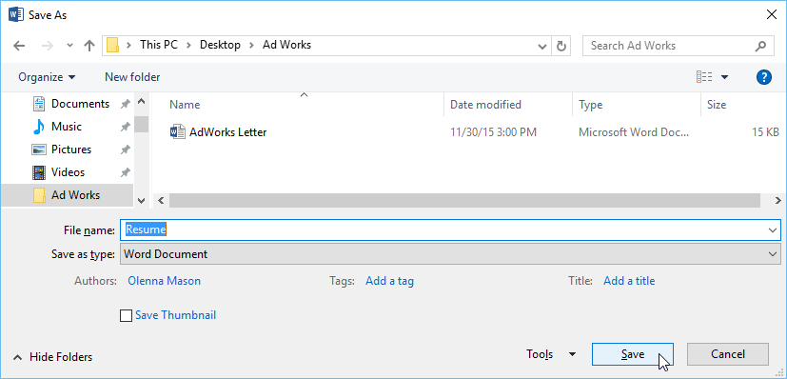

**Figure 4.3 (aa) Save As dialogue box**

* Enter a file name for the document, then click Save.
* The document will be saved. You can click the Save command again to save your changes as you modify the document.
* You can also access the Save command by pressing Ctrl+S on your keyboard.

DO YOU KNOW?

OneDrive is a file hosting service operated by Microsoft as part of its suite of Office Online services. It allows users to store files as well as other personal data in the cloud.



.

* **Printing a Full Document**

Once you have created your document, you may want to printit to view and share your work offline. It's easy to preview and print a document in Word using the Print pane.

* Select the File tab. Backstage view will appear.
* Select Print. The Printpane will appear.

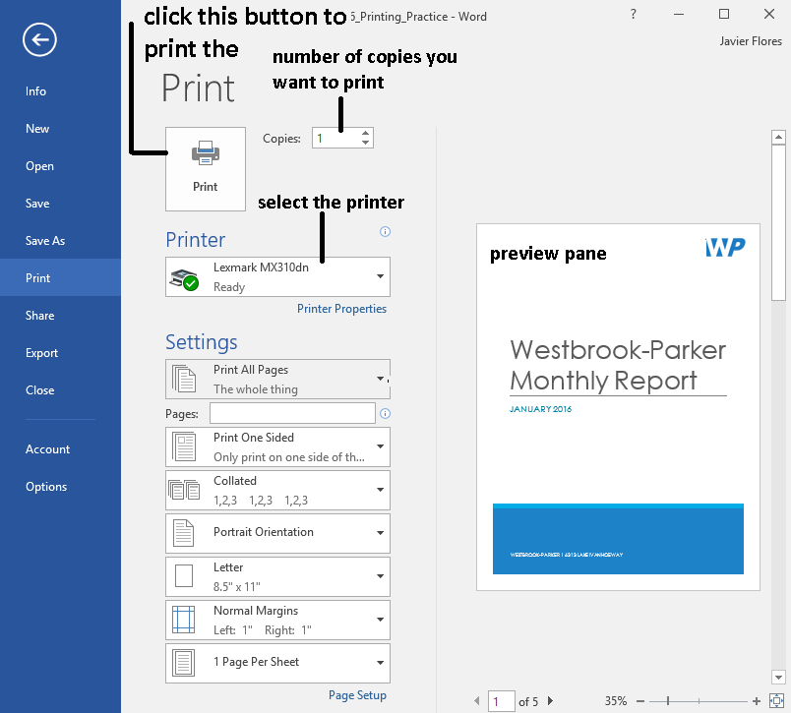

**Figure 4.3 (bb) Print window**

* Select the desiredprinter.
* Enter the number of copies you want to print.
* Select any additional settings if needed.

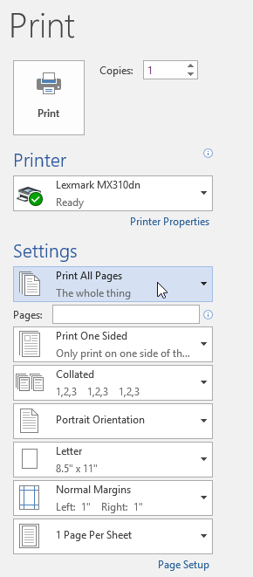

**Figure 4.3 (cc) additional settings**

* + **Print Range**

Here, you can choose to print the entire document, just the current page, or custom print to print specific pages.

* + **Single and Double Sided Printing**

Choose whether to print on one or both sides of the paper, if your printer supports this setting.

* + **Collated**

If you are printing multiple copies, you can choose how the pages will be sorted. Collated will sort them 1, 2, 3, 1, 2, 3. Uncollated will sort them 1, 1, 2, 2, 3, 3.

* + **Potrait Orientation**

Here, you can choose portrait (vertical) or landscape (horizontal) orientation.

* + **Letter**

You can choose the paper size you want to use, if your printer supports this setting.

* + **Normal Margins**

Here you can adjust the page margins.

* + **One Page per Sheet**

This option allows you to print more than one page on a single sheet or scale the document to fit a specific paper size.

* Click Print.
* The printer will start printing out your document.

# 4.3.1 Viewing and Formatting

* **Document Views**

MS Word has a variety of viewing options that change how your document is displayed.  There are five ways to view a document:

* **Read Mode**displays your document in full-screen mode.
* **Print Layout** is selected by default. It shows the document as it would appear on the printed page.
* **Web Layout**shows how your document would look as a webpage.
* **Outline** Using outline view you can view the document as an outline and show the outlining tools. This is useful if you are moving sections of your document, or creating an outline.
* **Draft** Use draft view to view the document as a draft, to enable you to quickly edit the text.



Activity 22

Select and see the difference between different *Document*

*Views* from the bottom right corner of your screen.

* **Formatting Commands**
  + **Margin Formatting**

You can change the margins of your document.

1. From the menu tab at the top of Word, select Page Layout.
2. In the Page Layout menu, the margins button will allow you to change the margins to the correct format.
3. Select Normal to set all margins to one inch.

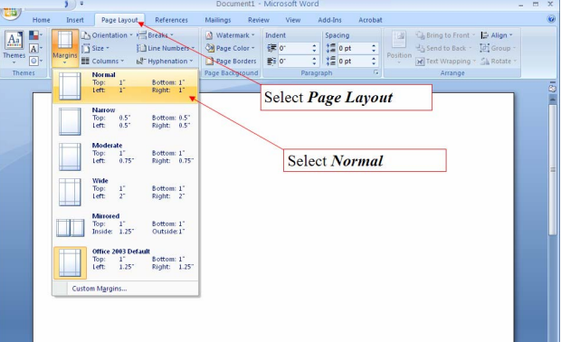

**Figure 4.3.1 (a) Margin formatting**

* + **Format Spacing**

You can adjust the line spacing of your word document.

1. From the menu tab at the top of Word, select Home.
2. In the Home menu, the Line spacing button will allow you to change the line spacing to your desired value.

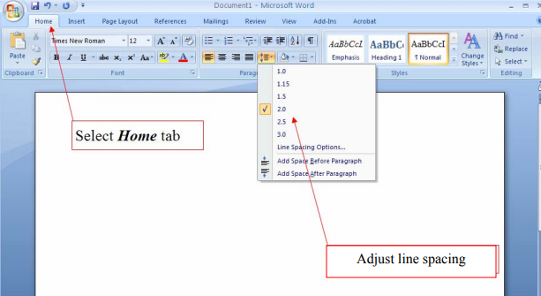

**Figure 4.3.1 (b) Line spacing**

* + **Format Paragraph Indents**

One of the most common reasons for indenting a paragraph is to set off quoted text from the rest of the document. Usually, you move the paragraph's left edge in about a half inch from the left margin.

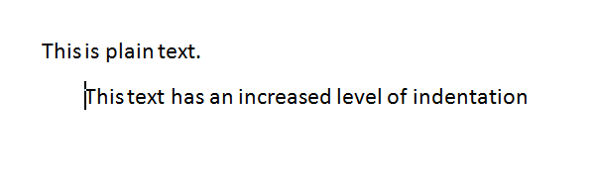

Word makes it easy to indent text in this way. Just use the Increase Indent button on the ribbon. If you change your mind and want to remove the indent, use the companion command Decrease Indent

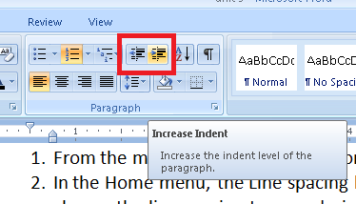

**Figure 4.3.1 (c) Indentation**

* + **Format Font Style**

1. Select the text you want to format, or place your cursor at the beginning of the line.
2. In the ***Styles*** group on the ***Home*** tab, click the ***More*** drop-down arrow.

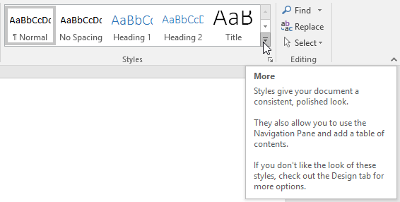

**Figure 4.3.1 (d) Font styling**

1. Select the **desired style** from the drop-down menu.
2. The text will appear in the selected style.

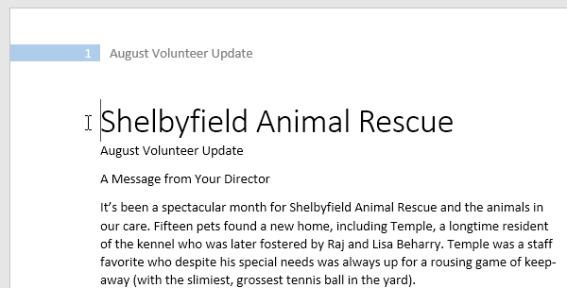

**Figure 4.3.1 (e) Selected style**

Activity 23

* Change the margin settings of your document to *moderate*
* Select the line spacing to 2.0
* Select a line and increase its indent level.
* Select a line and change its font style to “*Intense Emphasis”.*

# 4.3.2 Different FunctionsE:\MS\PTBB\geek-boy-laptop-cartoon-illustration-geeky-little-44146681.jpg

* **Undo**

It allows you to reverse the last command, or last few commands, that you performed.  The drop-down arrow next to the *Undo* button contains a list of your last few previous actions. You may reverse anything that is on this list by simply clicking it. The shortcut key for undo is *Ctrl + Z.*

* **Redo**

Next to the *Undo* button is the *Redo* button. The *Redo* command is the inverse of the *Undo* command. It will redo an action you have undone. This is valuable if you accidentally click the Undo button too many times. You can also use the keyboard shortcut *Ctrl + Y* to redo the last action undone.

* **Find**

When you're working with longer documents, it can be difficult and time consuming to locate a specific word or phrase. Word can automatically search your document using the **Find** feature.

1. From the **Home**tab, click the **Find** command. Alternatively, you can press **Ctrl+F** on your keyboard.

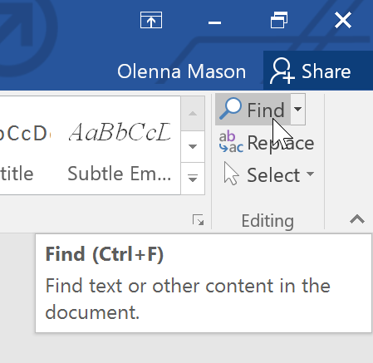

**Figure 4.3.2 (a) Find**

1. The navigation pane will appear on the left side of the screen.
2. Type the text you want to find in the field at the top of the navigation pane. In our example, we'll type the word we're looking for.

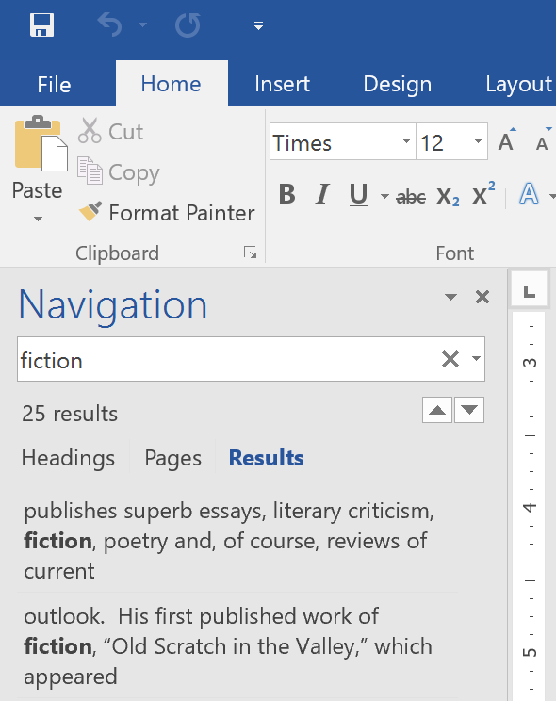

**Figure 4.3.2 (b) Navigation Pane**

1. If the text is found in the document, it will be highlighted in yellow and a **preview of the results** will appear in the **navigation pane**. Alternatively, you can click one of the results below the arrows to jump to it.

* **Replace**

At times, you may discover that you've made a mistake repeatedly throughout your document such as misspelling a person's name or that you need to exchange a particular word or phrase for another. You can use Word's **Find and Replace** feature to quickly make revisions.

1. From the **Home** tab, click the **Replace** command.
2. The Find and Replace dialog box will appear.
3. Type the text you want to find in the Find what: field.
4. Type the text you want to replace it with in the *Replace with:* field. Then click Find Next.

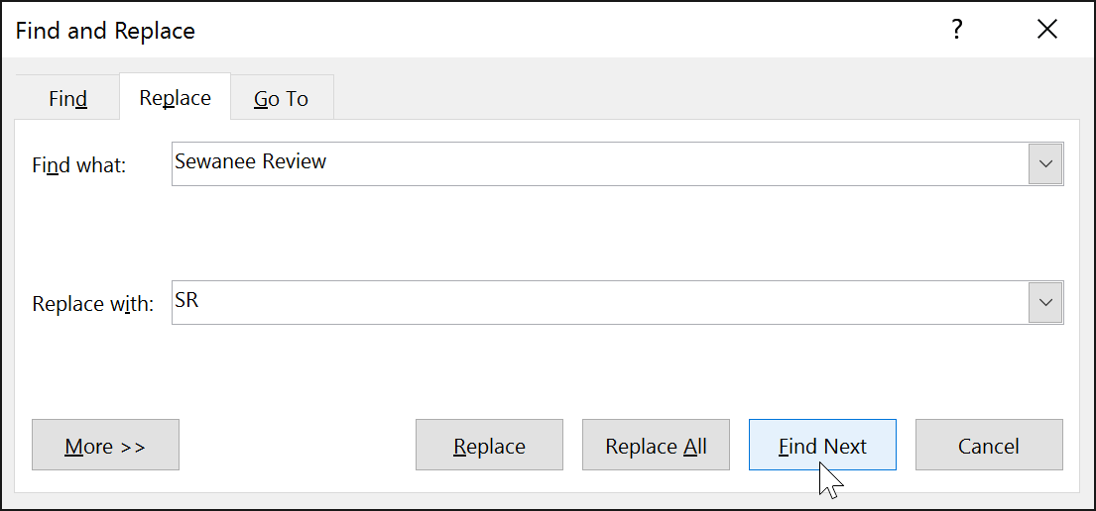

**Figure 4.3.2 (c) Replace**

1. You can select the options of *Replace* or *Replace All* to replace all instances of your word in one go.

Activity 24

* Type the paragraph under *“Format Paragraph Indents”.*
* Use *Find and Replace* feature to find the word *paragraph*

and replace it with *para.*



* **Making Tables**

A **table** is made up of rows and columns. The intersection of a row and column is called a **cell**. Tables are often used to organize and present information, but they have a variety of uses as well. You can use tables to align numbers and create interesting page layouts.

* 1. Click where you want the table in your document.
  2. Click the Insert tab.
  3. Click the Table button.
  4. Drag through the grid to set the desired number of rows and columns.
  5. You don’t need to be precise; you can always add or remove rows or columns later.

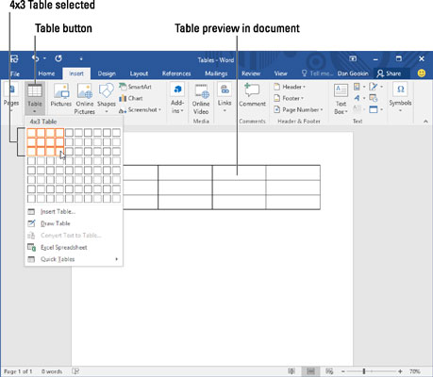

**Figure 4.3.2 (d) Making tables**

Activity 25

Draw a table with 2 columns and enter your marks that you

obtained in last term in the subjects maths, English, urdu,

computer and islamiyat.



* **Use Bullets or Numbering**

Word allows you to create numbered lists or bullets points in your document easily. To create lists follow these steps:

1. Position the [cursor](https://www.computerhope.com/jargon/c/cursor.htm) where you want to insert the bullet or numbered list.
2. On the Home tab in the [Ribbon](https://www.computerhope.com/jargon/r/ribbon.htm), click the bullet/numbered list button.

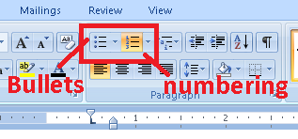

**Figure 4.3.2 (e) Bullets and numbering**

1. Your list will start. Type any text and press Enter to start the next bullet or number. To end the list, press Enter twice.
2. You can select different styles for bullets or numbering by clicking on the small arrows besides the bullets and numbering buttons.

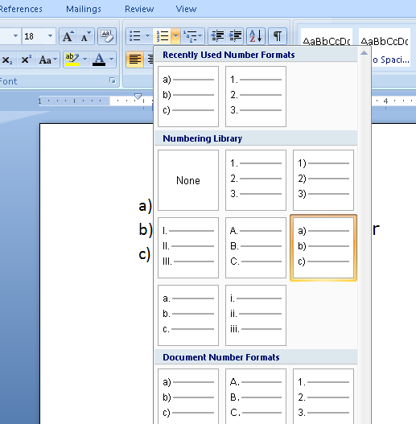

**Figure 4.3.2 (f) Different numbering formats**

Activity 26

Write down the steps for using bullets/numbering in your

document as written above. Select and try different types of

bullets and numbering format.



SUMMARY

* A **file** is a collection of data stored in one unit, identified by a filename.
* Folders allow people to organize their files in a way that makes sense to them.
* A **logical drive** or **drive** is a drive space that is logically created on top of a physical hard disk drive.
* Microsoft Paint is used to draw, color and edit pictures and graphics.
* With the pencil tool, you can draw a free form line or drawing with the selected line width.
* Fill with color tool is used to fill desired color in the selected area of the image
* The collection of colorful boxes at the top right of paint window is known as the **color palette**
* **Brushes** are more versatile than the typical pencil as you can use different brush tips to create different types of strokes.
* **Shapes** tab offers a wide variety of different shapes that can be drawn on the canvas
* The **outline** option is used to draw different types of outlines of the selected shape
* The **fill** option is used to fill the selected shape with desired brush strokes of selected color.
* You can also click the floppy disk image on quick access toolbar to save your file.
* **Word Processing** means to create, edit and print documents using a software on a computer.
* **Microsoft Word 2016** is a word processing application that allows you to create a variety of documents, including letters, resumes, and more.
* In MS Word, the ribbon is divided into seven tabs and each tab is a collection of several groups that show related items together
* The ruler is used to make alignment and spacing adjustments.
* Adding, deleting and re-arranging text in the document is called **text editing.**
* Before using any Word feature, a user must first **select** the required text. Selected text appears highlighted on the screen.
* The **copy command** creates a duplicate of the selected text, leaving the original text unchanged
* The **paste command** pastes the copied text at the insertion point.
* A user can move text from one position to another in a document using the cut and paste commands. The **Cut** command deletes the selected text from its original location
* Removing text from a document is known as **deleting**
* **Text formatting** allows you to change the appearance and layout of text and other characters within a document.
* The **font** determines the way your text appears on your screen and in your printed document.
* **Alignment** determines the appearance and orientation of the edges of the paragraph.
* The case of a sentence can be changed to lowercase, UPPERCASE, Sentence case, Capitalize Each Word and tOGGLE cASE.
* In spellings and grammar check, Ignore All will skip the word without changing it, and it will also skip all other instances of the word in the document.
* If you are printing multiple copies, you can choose how the pages will be sorted. Collated will sort them 1, 2, 3, 1, 2, 3. Uncollated will sort them 1, 1, 2, 2, 3, 3.
* There are three ways to view a document: read mode, print layout and web layout.
* You can format the margins, line spacing, style and indentation of your document.
* *Undo* you to reverse the last command, or last few commands, that you performed.
* The *Redo* command is the inverse of the *Undo* command. It will redo an action you have undone.
* Word can automatically search your document using the **Find** feature.
* You can use Word's **Find and Replace** feature to quickly make revisions.
* A **table** is made up of rows and columns. The intersection of a row and column is called a **cell**. Tables are often used to organize and present information, but they have a variety of uses as well.
* Word allows you to create numbered lists or bullets points in your document easily.

EXERCISE

**Q.1 Tick the right choice**

1. Paint is a _______ software

A) graphics B) word processing

C) Typing D) Mathematical

1. ________ tool can be used for picking a specific color from any part of the picture.

A) Fill with Color B) Color Picker

C) Magnifier D) Eraser

1. ________ is used as a fill whenever a closed object like circle, rectangle etc is drawn or to fill a deleted area of the image.

A) Color 1 B) Color 2

C) Color 3 D) Color 4

1. ________ creates strokes similar to that used to create an oil painting.

A) Airbrush B) Crayon

C) Watercolor Brush D) Oil Brush

1. ________ tool is used to fill the screen or a closed shape

A) Pencil B) Fill with Color

C) Eraser D) Text

1. To reduce the size of an image by 50%, select ________ option from Image group.

A) Rotate B) Select

C) Resize D) Crop

1. ___________ allow people to organize their files in a way that makes sense to them.

A) Files B) Briefcase

C) Folders D) email

1. The **_____ drive** is the main hard disk partition which contains the operating system and the related system files

A) C B) D

C) E D) F

1. in Windows 10, select the option *_________* to cut and paste a file

A) copy to B) move to

C) cut and paste D) transfer to

1. The software used to produce text documents on a computer is called a ______________

A) word processor B) typing tutor

C) Media player D) calculator

1. **___________** contains all of the commands you will need to perform common tasks in Word

**A)** title bar B) Ribbon

**C)** status bar D) Ruler

1. Before using any Word feature, a user must first **________** the required text.

A) Copy B) Paste

C) Select D) Cut

1. To use the cut command, select the text and click the Cut option in the clipboard tab or press

A) Ctrl + X B) Ctrl + C

C) Ctrl + A D) Ctrl + Z

1. displays your document in full-screen mode.

A) Print layout B) Reading mode

C) Web layout D) Normal layout

1. ________ command allows you to reverse the last command, or last few commands, that you performed.

A) reverse B) undo

C) rewind D) redo

**Q.2 Fill in the blanks**

1. __________ can be used to draw a free form line or drawing with the selected line width.
2. **______________** is shown by the box labeled as Color 1 on the left side of color palette.
3. _________ mimics the use of an actual airbrush.
4. The drop-down arrow next to the *_______* button contains a list of your last few previous actions.
5. You can use Word's **____________** feature to quickly make revisions.
6. **_______** is a collection of several groups of related commands in Word.
7. **____________** shows how your document would look as a webpage
8. A flashing vertical line on the screen is called **cursor** or **___________.**
9. To select the entire document, move the mouse pointer to the left of paragraph until it changes to a right-pointing arrow and then ____________
10. While _____________ can store several gigabytes of data, they themselves hardly take up any space on the hard drive.

**Q.3 Define the following**

1) File 2) Alignment

3) Text Formatting 4) Print Layout

5) Folder 6) Brushes

7)drive 8) Undo command

**Q.4 Differentiate between the following**

1) Brush and Pencil 2) Justify text and Centre text

3) Foreground and Background colors

4) Cut and Copy command 5) Outline and Fill option

6) Undo and Redo command

**Q.5 Give short answers to the following questions**

1. What are the steps for launching MS Paint in Windows 10?
2. What are the main tools available in Paint tool box?
3. Name and define any 3 types of brushes.
4. What are the 3 methods for deleting a file/folder?
5. How can a user move text from one position to another in a document?
6. What is quick access toolbar?
7. List and define the available options for changing case of font in MS word.
8. What are the available document views in MS word?
9. How can you select a paragraph in MS Word?
10. Write down the steps to insert a table.

**Q.6 Match the columns A and B and write matching pairs in column C.**

|  |  |  |
| --- | --- | --- |
| Column A | Column B | Column C |
| 1. Folders | a) Paste text |  |
| 1. Text Tool | b) BICYCLE |  |
| 1. Verdana | c)Office Online |  |
| 1. Table | d) Insert text into picture |  |
| 1. Ctrl + V | e) pointers to files |  |
| 1. UPPERCASE | f) page size |  |
| 1. Ctrl + S | g) free form drawing |  |
| 1. OneDrive | h) cell |  |
| 1. Letter | i) Save file |  |
| 1. Pencil | j) Font |  |

**Q.7 Label the following diagrams.**

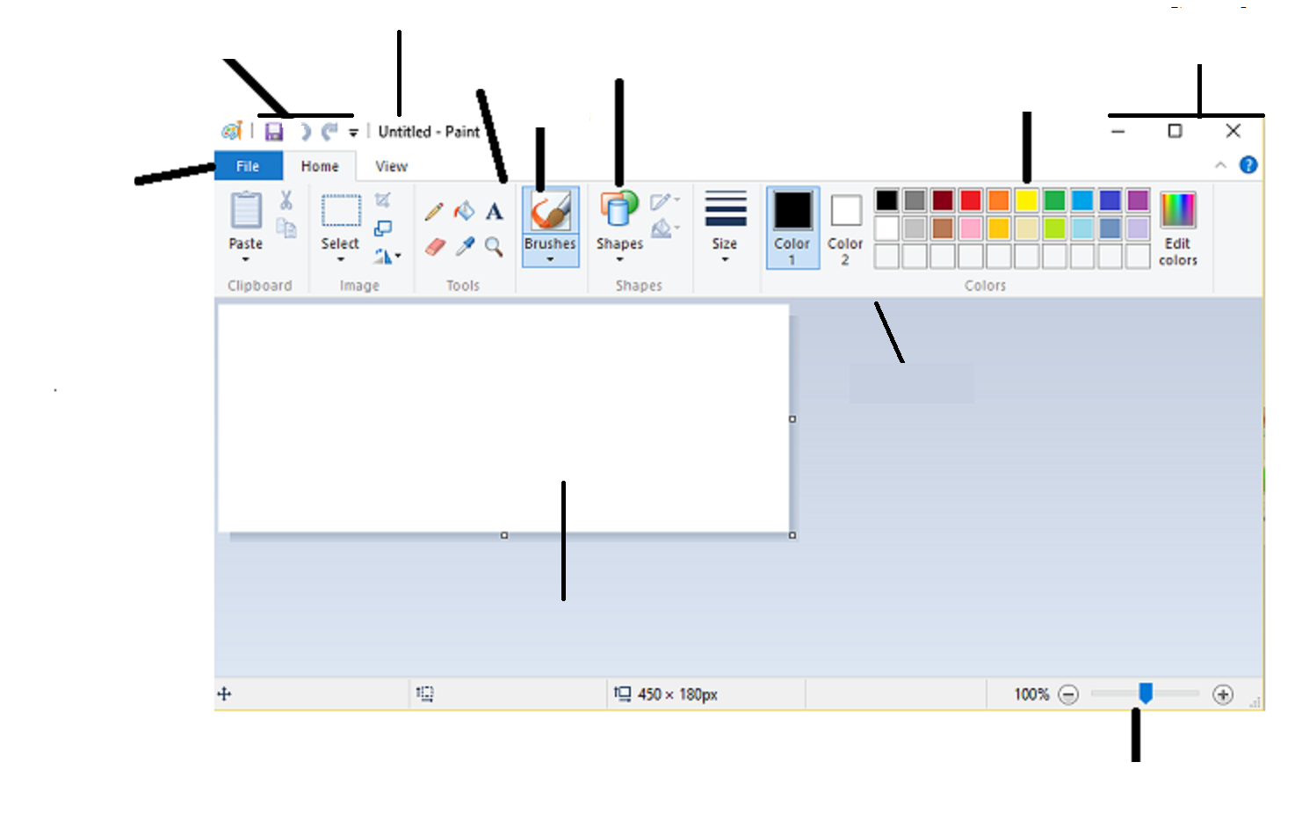

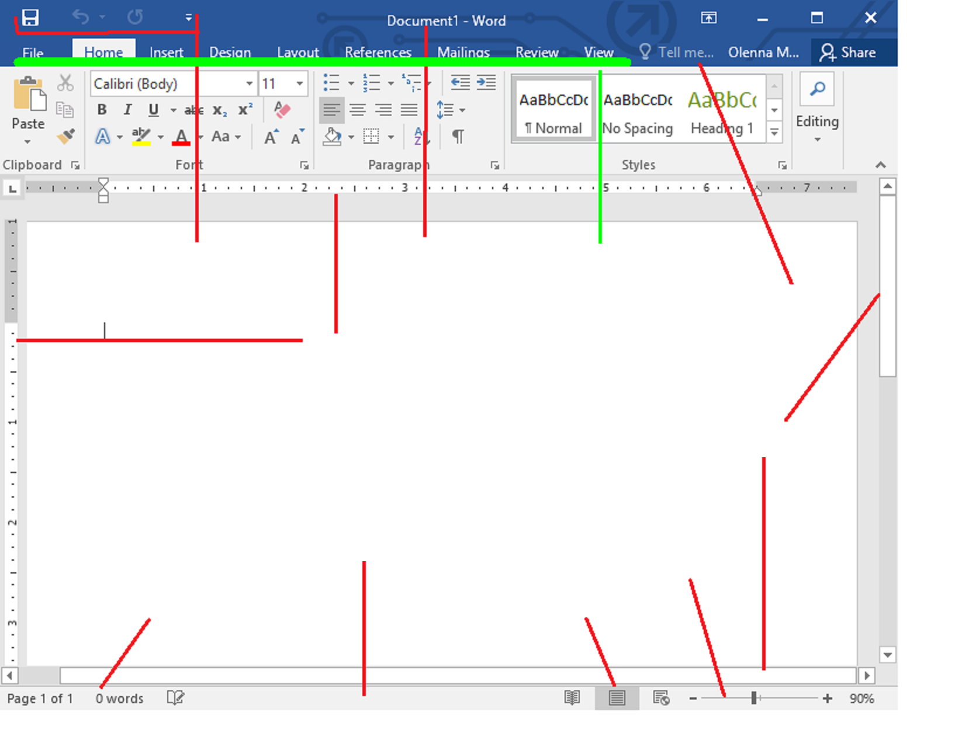

**Lab Activity 1**

Design a flag for your school.

* Start by drawing a rectangle with the help of rectangle tool.
* Your flag must have atleast three different colors.
* Name of your school must be written on the flag.

**Lab Activity 2**

Design a new cartoon character. Be creative!

* Your character must use atleast three different shapes
* It must have atleast five different colors
* Write “Designed By” and your name somewhere near your drawing.

**Lab Activity 3**

Draw a tree.

* Select brown color from color palette and use thick brushes to draw stem and branches of the tree.
* Select green color and use airbrush to draw leaves.

**Lab Activity 4**

Draw face of your best friend.

1. Use brush tool for drawing the face
2. Use airbrush for drawing the hair
3. Be creative with your friend’s hairstyle!
4. Write your friend’s name in a colored font somewhere near your drawing.

**Lab Activity 5**

Design a picture that contains the following

* Any building (a house, a skyscraper, barn etc)
* A sky with clouds and a sun or a sky with stars and a moon
* Atleast two trees
* Atleast five flowers
* Other items may be added as you wish

**Lab Activity 6**

* Type your first name
* Copy and paste it 10 times
* Press Enter after each name
* Make the font size of each name bigger than the previous one
* Each name should have a different color

**Lab Activity 7**

Make a banner for your school annual funfair

**Funfair**

**Please join us in the school ground**

**for annual funfair**

**Monday, October 15, 2018**

* Open a new document and save it as Banner.
* Select font Rockwell, font size 22, font color red and Centre alignment.
* Write ”Funfair” and press enter.
* Select font Calibri, font size 16, font color black and press the button **B**.
* Type “**Please join us in the school ground for annual funfair**”
* Type Enter.
* Select font color blue.
* Type “**Monday, October 15, 2018”.**
* Now click on Insert tab and select Shapes command from the Illustrations group.
* Look for the banner shape.
* Draw the shape over the text.
* Select the shape by double-clicking on it.
* Word will open the Format tab.
* Select No Fill option from the Shape Fill command.
* Use the small blue squares around the banner to adjust the size of shape.

**Lab Activity 8**

* Open a new document and save it as Application.
* Select font as Times New Roman.
* Type the following text
* NOTE: the main body of application should be “justified”

Sick Leave

To

The Principal,

Govt. Islamia High School,

Multan.

Sir,

I respectfully beg to state that I am sick and therefore unable to attend the school. Kindly grant me leave for **one day.** I shall be very thankful to you.

Yours Obediently,

Shahzad Khan

Class 6th-A

Roll Number 15

**Lab Activity 9**

* Change this line to your favorite color.
* Centralize this line.
* Italicize this line.
* Change this line to size 28.
* Make this line bold
* Change this line to capital letters.
* Underline this line.
* Change this line to Arial.
* Below this line, add a shape of your choice.
* Below this line, add your name using green color in Bold and underline it.

**Note**: all of these lines should be in the form of a bullet list

**Lab Activity 10**

* Type “I am a student of class 6”
* Copy and paste it 10 times and press Enter after each line.
* Choose a different font color and font style for each line.
* Write the name of font used in front of each line.
* All lines should be numbered from 1 to 10.

**Lab Activity 11**

* Create a folder in Drive D and name it after your name
* Open the folder
* Create a new Word file in that folder
* Rename it as ‘*class 6’.*
* Copy this file
* Open Drive E and create another folder after your name.
* Open this folder
* Paste the file you that you copied previously in this folder